!! REMINDER !!
* NOTICE OF NEXT MEETING *
MON 12th NOVEMBER 2007 SHAW’S BRIDGE 7.45 pm

Guests: Kyle McCallan & Andrew White

[Trevor Henry Bursary Weekend Report continued]
in the middle on 3 occasions for inspections. It was interesting to listen to captains, umpires and groundsman [the most important of the 3 parties] discuss conditions. Both Jeff Evans and Nigel Cowley took back seats to the others until needed which proved an extremely painless approach.  Unknown to me, Nigel had been feeling “off-sorts” and a paramedic had examined him a few times during the previous 3 hours. Getting close to the bell I left the umpires and went downstairs to talk to the commissionaire. He had mentioned to me earlier that it would be great if I could get involved – I agreed, but was extremely happy and content with my present level of involvement. Imagine my shock, never mind heart rate, when Jeff approached me two minutes before the bell and asked me to get dressed and accompany him into the field as Nigel was not well.  I took no persuading – quickly relieved Nigel of his top, used Jeff’s spare footwear and also Nigel’s 6 two pound coins and headed down the steps to the middle. Going to the so-called “non-business end”, I was called upon to make 3 run-out decisions [relatively straightforward!].  The match went to the last over with the home team winning. An unbelievable experience had ended – for the meantime. At this stage it hadn’t sunk in yet, and it wouldn’t until a | number of hours later. Standing on the balcony with “light” refreshment looking over an empty ground brought it home to me how lucky I was. A truly wonderful experience had come and gone but would live with me forever.  In summary, I have a lot to share with my colleagues in NIACUS and my thanks go again to all who made it possible.  A Neill  Many thanks to Alan for this short [and he admits deliberately abbreviated] account of his recent experiences. I know this is but a brief outline of a special weekend for him and we all look forward to sharing the highlights and worth of his time on the Bursary weekend during our winter meetings which he wishes to do. I know Joe would like him to provide a little more detail in person and I know Alan has a lot he would like to share and discuss with us and which he began at the AGM. Ed.  I saw much better batsmen than I was. Lots of them . . .  . . . they just kept getting out – DON BRADMAN  16 aw o7
Northern Ireland Association of Cricket Umpires & Scorers

 THE FOLLOW-ON

October 2007 Issue No 123

LIVERPOOL JIM CALLS ‘TIME’ ON ‘THE FOLLOW-ON’
by Paddy O’Hara
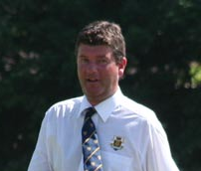 Now that actor, writer, producer, director and stage hand Alan Waugh is safely installed as our new Editor, it is appropriate that NIACUS records its grateful thanks to his predecessor Jim Morrow.  It was back in December 2002 that Jim bravely accepted the challenge of continuing the production of our magazine. I say 'bravely' because he was first to admit that he hadn’t the computer sophistication of John Boomer whom he was succeeding. However, typical of the man, he got stuck in and was determined to make a success of the job, with the same determination and attention to detail that he had shown in his umpiring career. He even enrolled in night classes in order to improve his ‘technical skills'.  Not surprisingly, then, he has been our longest serving Editor, producing no fewer than 33 editions up until his 'retirement' in April of this year. | Jim has always shown tremendous enthusiasm for his umpiring - and for NIACUS - and had risen through the ranks to Interprovincial level, before a combination of work commitments and family illnesses caused him to have to hang up the white coat. We very much hope that these circumstances will alter in the future and that we may see him back on the field, doing the job he enjoyed so much. We can ill afford to lose umpires of Jim’s calibre.  As with all our previous Editors, Jim put his own stamp on his productions and he introduced as regular features, Diary of the Season, Puzzlers, the excellent field technique pieces and, of course, his beloved poems. The only surprising omission was a regular report on the fortunes of Liverpool F.C. - an even greater passion of his, than umpiring was.  Thank you Jim, for your sterling efforts. NIACUS owes you a great debt of thanks.  PLO  

It is hard to tell where the MCC ends and the Church of England begins.
JB PRIESTLY 1
 |  | 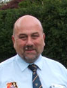
Well, there we go. September issue come and gone (generally satisfactory I’m led to believe) and here’s the October issue upon us with the logo returned to normal size for Keith!  What have we got? Well The Instructor gave us plenty of food for thought and there are a couple of interesting responses, in particular John Boomer, as well as a very relevant piece which Peter Shields allowed me to reproduce from The Ulster Cricketer. There is also a welcome return of Ian’s Diary.  We have our first From the Chair from Joe who I’m sure will use his splendid personality to the benefit of the Association though his fielding technique cost me a wicket recently! | There is, too, sad to say, a report on our heroic attempt to regain The White Stick, and some customary invaluable Fieldcraft advice from our esteemed instructor from a past issue.  The Post Box has got off to a light but pleasing start, and I urge you to take advantage of it.  And finally, may I personally echo completely Paddy’s tribute to my predecessor Jim Morrow.  Don’t forget to have a look at our new web version of The Follow-On at:-  http://thefollowonline.blogspot.com/ where you’ll see the 1st of our umpire profiles.  AND don’t forget the ACUS Ireland EGM at Stormont 21 October 3pm!*****

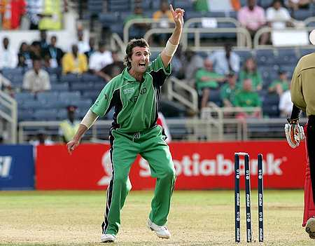 | WORLD CUP DUO TO  GUEST AT NOVEMBER  MEETING !! |  | CONTENTS  Page Item  2 Editorial & News  3 From the Chair  4 White Stick Trophy  7 Post Box  8 Afternoon Post  9 Don’t Kill the Goose  10 Fieldcraft  11 Ian’s Diary  12 More of the Season  13 Alan Neill Report  14 From the Forum  15 Reflections on Sept  Fieldcraft
 | BOOK YOUR SEATS EARLY! Ireland’s top all-rounders Kyle McCallan & Andrew White will be top of the batting order at our next meeting at Shaw’s Bridge on 12 Nov. They will be telling us, in their usual entertaining & forthright style, of their experiences in the West Indies during the World Cup and we look forward to a highly entertaining & informative evening. Be there!
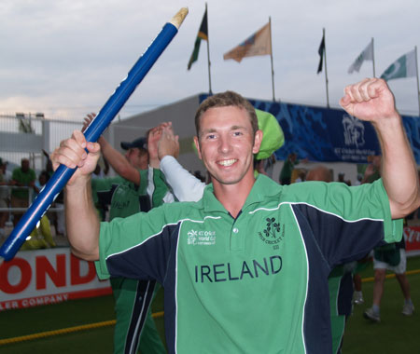
2
REFLECTIONS ON LAST MONTH’S FIELDCRAFT COLUMN

The instructor produced an excellent article on setting and maintaining standards.  I just wonder if, in general, standards of behaviour are declining and what can umpires and governing bodies do about it.  Interestingly the ICC was seriously concerned about the conduct of players and realised that poor behaviour at the top level, where most matches are covered on television, was being copied in matches at lower levels.  So the ICC set out its standards, its levels of offences and associated penalties and finally named and shamed. Evidence to date is that the system has worked. Players have been clearly briefed on the system and umpires and other officials trained in its application.  Many national governing bodies have now adopted the ICC code fully.  The ICC code has 4 (one more than the NCU) levels of offence – the first Level 1 is for minor misdemeanours, the maximum penalty is a reprimand and there is no appeal. The NCU has basically combined the ICC Level 1 & 2 offences.   | I would suggest that to improve behaviour we should be reporting more (minor) breaches; in most cases there will be little doubt about the guilt of the individual who would receive a caution. Arrangements should be made to have a hearing within days and not weeks. And the outcomes should be publicised to discourage re-offences.  Players will always push the boundaries of acceptable behaviour. As instructor points out each umpire has his own level of tolerance – but players usually perceive this as being inconsistent.  Maybe it is time to:  (A) Bring the current code into line with the ICC Code. (B) Adopt a policy of Zero tolerance and ensure players are fully aware what is not acceptable. (C) Deliver training on the code of conduct for all officials (mandatory to attend). & (D) Clearly identify who can report, for example: Umpires; Home Team management; Away Team management; President of the Union.  There is no doubt, that such a course of action would require a joint and agreed approach of the Umpiring Association and the Governing body.  John Boomer

It is a game which keeps boys out of mischief – PROFESSOR CASE
15
 THE PUZZLER SOLVED 

N.B. ALL signals to scorers are made ONLY AFTER the ball is dead. They are made and acknowledged separately.
In this scenario, the ball is automatically dead the instant the ball strikes the parked helmet, so the ball travelling on to the boundary is irrelevant.
1. 5 penalty runs - (to the batting side) - 'patting for batting'
2. No ball.
3. Bye - to indicate that the striker did not hit the ball with his bat.

1 No ball extra and 5 penalty runs = a total of 6 runs are scored.

[extracted from the cricketeurope Ulster forum]
White Stick Trophy  This is a brief note to thank all those who have contacted my wife and myself to enquire after my health following my non-appearance on the NCU team on Sunday.  I was shocked and disappointed to see that I am listed as "DNTU". More like "DNKAG"!  I would state at the outset for the benefit of PLO'H that I did not run out of petrol! To clarify my position I would confirm that some 10 days ago I was approached about my availability and while I was certainly willing to play, I received no further notification. I was assuming that I would be contacted about the venue, hours of play, dress code, etc.  It is clear from the disastrous result that | to omit a player of my skill and talent was a glaring mistake by the selectors.  I take this matter very seriously and I would advise that I am now considering my position within Irish cricket in respect of selection for the Irish team and indeed for any inter-Pros that may come up! Also I am not interested in any contract for next season so don't waste any time approaching me! Some may say that I should have contacted the organisers to see if I was required but those who really know me are aware that I am a very unassuming guy and I would not presume to dare approach such an august body. I must confess that I really would have had difficulty in dealing with the disappointment of rejection!! Andy Kennedy  NIACUS team not NCU team Andy!!

I never play cricket. It requires one to assume such indecent postures.
- OSCAR WILDE
14
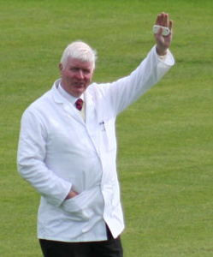  Hi. It’s me! |   From the Chair  Welcome to The Follow-On
In this, the first issue since you did me the honour of electing me Chairman, I would like to thank my predecessor, Joy, for her hard work, and trust that she has a happy “retirement”.
Congratulations to Alan Waugh and Alan Chambers for their outstanding contributions to The Follow-On and the Website. Jim Morrow did sterling work and he will be missed.
The past season has been blighted by controversy on the pitch, with a huge increase in disciplinary offences, and, following this, unfortunately, some of our colleagues may well decide to hang up their coats. The Association will continue to support colleagues caught up in disciplinary proceedings, and will offer all possible assistance. We will continue to make representations to the NCU on this matter.
This promises to be a highly challenged close-season and all umpires are reminded that on 21.10.07 an EGM of ACUS – Ireland Region takes place at Stormont Clubhouse. Please make a special effort to attend.
See you all on 12th November.
Joe
AGM REPORT  Joy thanked members present for a good turnout. The minutes of the 2006 AGM were adopted on the proposal of Paul Boreland & Arthur Thompson. Some lengthy discussion on colleague reports & assessment in general took place under Matters Arising with the undertaking that this area would be subject to continued review. Keith presented the meeting with a very comprehensive Secretary’s Report which can be read in full on the website. In Trevor’s absence, the Treasurer’s Report was presented by Sylvan Reid. This was adopted on the proposal of Joe Moore & Nigel Smith. |  | Our President, Peter Lunney took the Chair for the election of officers. The following were returned:  Chairman: Joe Moore Vice-Chairman: Noel McCarey Hon Secretary: Keith Smith Hon Treasurer: Trevor Magee Appointments Sec: Ian Houston NCU Rep: Alan Neill Committee Members: Paddy O’Hara; Paul Boreland & Judith Hewitt.  A new list of Vice-Presidents was also approved. Nominees are to be contacted and a list will appear in next issue.  Alan Neill gave a little insight on his Southampton visit [see page 13]. And then confession time! As this magazine is for public consumption details are being kept highly confidential unless those members present care to spill the beans!!

And Ian Greig’s on eight, including two fours – JIM LAKER
3
Leinster Umpires Retain White Stick Trophy
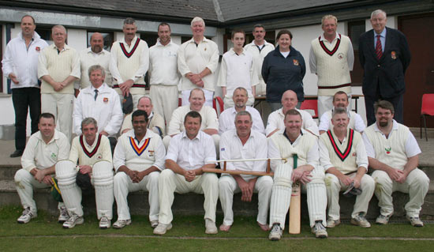
The good weather did not shine on the NIACUS bid to win back cricket’s most prestigious trophy – THE WHITE STICK – at The Demesne, Saintfield on Sunday 23rd September, when they fell victim to an obviously unwarranted 6 wicket defeat at the hands of their southern foes who, sad to say, now go 10-8 up in the series. Our last victory was during Alan Waugh’s period in the Chair!  Having won the toss and electing to bat on what appeared to be a road, pressure mounted as runs came slowly on the tarmac which had been MISTAKENLY judged to be set! Openers Neill and McCall [FOOLISHLY having been advised by his skipper to “take a look”] could only take the score to 23 in the 9th over before Captain Neill played all round a seemingly innocuous delivery from T Mooney. McCall [JF] followed suit stumped by Dwyer off the bowling of Leinster PRO Desai but only after having faced 33 balls in 40 minutes for his 6 runs! | The picture improved a little with the entry of Messrs McConville and host McCarey with a 31 run 3rd wicket partnership that seemed to be turning the tide. When a 2nd stumping [you’d think we’d learn!] removed McConville, McCarey fortunately continued the assault on the Leinster bowling in tandem with Frater, adding another 26 runs before he sadly fell victim to veteran Russell with the score on 86.  Then, as overs began to run out a bit of panic set in among the debut batsmen allowing Dwyer a 3rd stumping as Deegan tried to push the score along, and, by this stage, as bowling standards seemed to deteriorate and batsmen who had been dismissed earlier were ruing their luck, the innings closed frustratingly at only 113 for 6 off the allotted 30 overs. Think how different things would have been if Waugh and Moore had got to the crease and Kennedy had turned up! Clearly things were going to be tough in the field and early wickets vital.
4
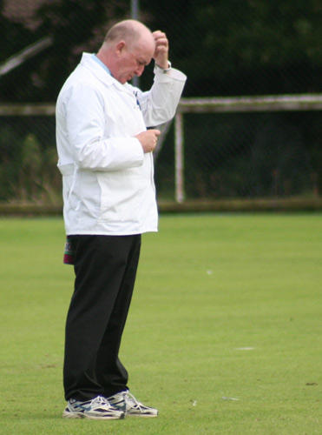 | ANOTHER LITTLE PUZZLER | 

A No ball is called. The striker swings at the ball but misses. The ball deflects off his pad, evades the wicket keeper, strikes the fielding helmet parked on the ground behind him, and goes on to cross the boundary.
Which signals and in which order should the umpire make (repeat) to the scorers - and what has been scored?

by Alan Neill  Firstly, let me thank all those persons who contributed in any way towards the Bursary. The experience I had in England is one I will never forget. Let me explain why.  Saturday 28th a.m. and leaving Belfast City, I headed for Southampton soaking up the atmosphere of what might lie ahead | 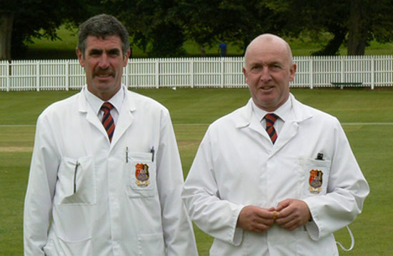
at the last day of a four day game, watching two top umpires handle two top teams – Hampshire v Sussex – and being allowed an insight into the preparation and running of this high level event leaving me full of anticipation.
After a short taxi ride to the hotel from the airport and a quick signing in, I headed straight to the Rose Bowl. What timing! I had missed only 4 deliveries as the start was slightly delayed due to overnight rain. The first two days had been washed out and so there was still a lot to play for in bonus points.
I got the chance to speak to both umpires at the interval and they invited me to their room. It was interesting to note the well stocked fridge full of fruit and water – I know that might disappoint some of my colleagues but at this level nutrition is very important.
The day went smoothly and a long chat over a cool beer ended the day at approx 8pm. Halfway through the experience and it was going according to plan. On the way to the hotel I couldn’t help thinking how lucky I was to experience this level of interaction.
Day 2 began with play to start at 2 pm – a 40/40 match, opponents Essex. The start was delayed to 3.45 – overs reduced which left me time to join my colleagues
[continued on back cover]
13
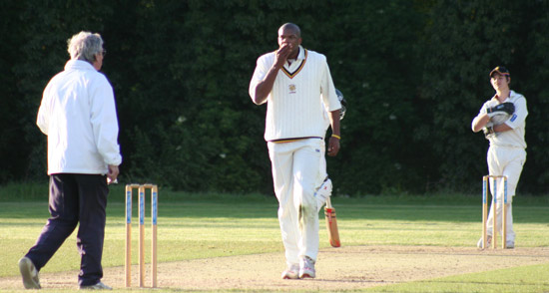  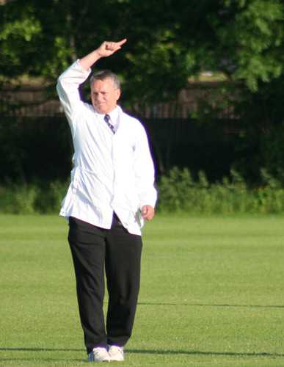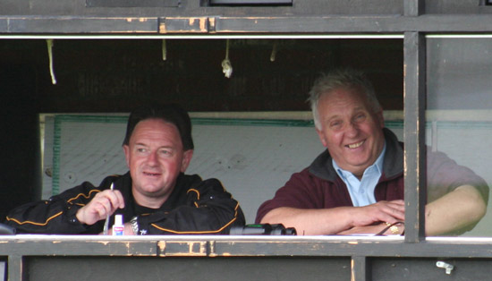 | [Ian’s Diary continued]  If they hadn’t come down to earth after the World Cup before, they certainly had now! Just time to fit in another Premier League game before the international action resumed. Carrickfergus v North Down was close for 34 overs as the visitors took that long to bring up the 100. They added 112 in the remaining 16 overs however and that settled the match, Carrick needing a last wicket stand of 22 just to get to three figures.  W/E SATURDAY MAY 19 - Back to Clontarf on Sunday for Ireland’s fifth game in a fortnight - and a fifth loss, in spite of 88 from William Porterfield. A target of 228 proved no problem for Essex and although Trent Johnston and Andrew White bowled 16 overs between them for 58 runs, Essex needed less than 42 to get the runs. The overseas stars are not proving a success. Jesse Ryder, a Kiwi who couldn’t lace Ewen Thompson’s boots, scored two, which was double his score on his debut against Gloucestershire and Nantie Hayward is consistently going at six runs an over, and against Essex he didn’t even get a wicket. After five days without cricket, it was Irish Cup day on the Saturday and Bangor proved no match for Limavady at Upritchard Park. Even the home supporters, however, could watch and admire Decker Curry as the former Ireland international rolled back the years to give Limavady a nine wickets win. He scored 75 from 62 balls as they totalled 190 in just 32 overs.  Ian Callender  More next month  

!! The answer to one of Paddy’s suggested quiz questions is on this page !!
CLUE: He’s even holding his hand up to the accusation!
What do they know of cricket who only cricket know – CLR JAMES
12
NIACUS opened their attack with Neill and Waugh but the hard-hitting Leinster openers Andrews and J Mooney made life difficult for the home side, and Waugh [unusually out of form] was removed from the attack after 3 overs at a cost of 31 runs during which McCall had to leave the field injured when diving to attempt to stop a driven 4 his head collided with the concrete at the boundary! And it wasn’t until the 13th over that that man McCarey, again, made the breakthrough with the wicket of Andrews with the score on 79. Umpire O’Hara felt this was due in part to some sledging from Waugh at slip but rightly took no action as we’d got the first of the danger men out. Frater, too, had by this time come into the attack and things looked brighter with his removal of the Leinster PRO Desai after only 3 balls for 6. The North’s youngest umpire, Josh Chambers, also bowled a couple of useful overs at this stage casting uncertainty on the enemy. And, as the clouds darkened, and the men from the South were coasting to victory, things almost came back within NIACUS reach when association vice-chairman Moore was introduced by Neill [patently too late!] into the attack to take 2 wickets for 1 run in one over! But by this stage it was too late and an ungainly four by Dwyer took the LCU&SA home by a lucky 6 wickets.  After the game, thanks were extended to the host club for its tremendous hospitality in providing the ground, lunch and evening meal. The awards of Man of the Match [Joey Mooney] and Champagne Moment [Joe Moore for his 1st ball dismissal of the Man of the Match with a double bouncer!] were made by President Peter Lunney. The teams exchanged various threats about the outcome of next year’s fixture, and Paddy O’Hara lamented long resulting in many mystery mobile phone calls suddenly coming in! | 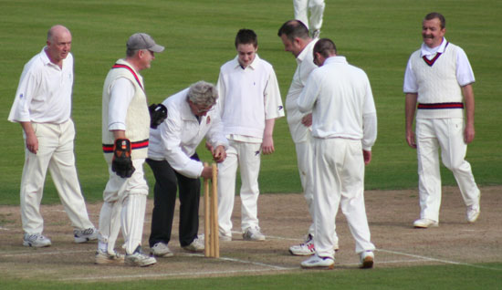  How many umpires does it take to repair the wicket?  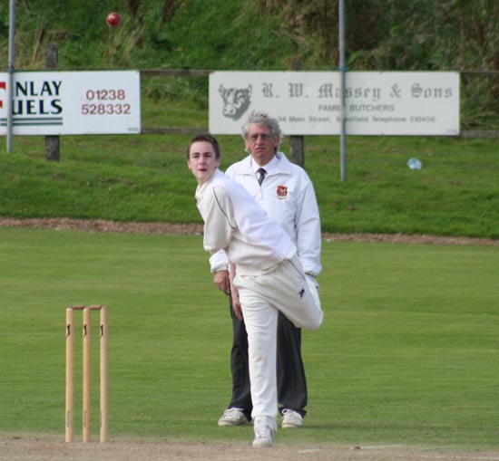  Josh Chambers gives the ball some air  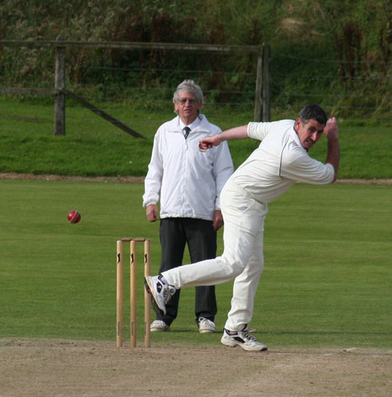  Noel McCarey bowling for NIACUS  (looks like a tango doesn’t it)  5

SCORECARD
THE WHITE STICK TROPHY
Venue: The Demesne Date: Sunday 23rd September
Umpires: P O’Hara NIACUS and P Thew LCU&SA

Innings of NIACUS
1 A Neill Bowled T Mooney 18
2 J F McCall St. M Dwyer U Desai 6
3 K McConville St. M Dwyer M Carter 11
4 N McCarey Bowled M Russell 37
5 A Frater Bowled N Parnell 11
6 J Chambers NOT OUT 3
7 T Deegan St. M Dwyer N Parnell 12
8 A Chambers NOT OUT 2
9 A Waugh DNB
10 J Moore DNB
11 A Kennedy DNTU ! ! ! Sorry DNKAG [see From the Forum Page 14]
Extras 13
TOTAL 113 for 6 in 30 overs
FOW
1-23 2-29 3-60 4-86 5-97 6-110
G Mooney 4-0-10-0 J Mooney 4-1-7-0 T Mooney 6-1-13-1 U Desai 4-1-9-1
M Carter 6-0-33-1 M Russell 4-0-18-1 N Parnell 2-0-15-2

Innings of LCU&SA
1 J Andrews Bowled N McCarey 40
2 J Mooney Ct. Neill J Moore 47
3 U Desai Bowled A Frater 6
4 J Gallagher NOT OUT 7
5 K Gallagher Bowled J Moore 0
6 M Dwyer NOT OUT 5
7 T Mooney DNB
8 N Parnell DNB
9 M Carter DNB
10 G Mooney DNB
11 M Russell DNB
Extras 10
TOTAL 115 for 4 in 20.3 overs
FOW
1-79 2-86 3-109 4-109
A Neill 5.3-0-25-0 A Waugh 3-0-31-0 A Frater 6-0-20-1
J Chambers 2-0-18-0 N McCarey 3-0-12-1 J Moore 1-0-1-2

Result: LCU&SA won by 6 wickets Man of the Match Joey Mooney
Champagne Moment J Moore – for his 1st ball dismissal of the Man of the Match with a DOUBLE bouncer
6
  Ian's Diary  SATURDAY APRIL 28 - Here we go again. Only 11 days after I returned from the World Cup and just four days after welcoming the victorious Ireland squad back to Dublin Airport after their 54-day marathon in the Caribbean, it was off to The Lawn for the first Premier League game of the season. Waringstown, the team who finished second but declared champions in 2006 at home to Instonians who were expected to do well in 2007. The champions lost but as they were without their three best batsmen it was hardly a surprise. Bowled out for 136 was not in the script, however, and Instonians lost only two wickets in getting the runs. And it wasn’t just Waringstown who were under strength; Andrew White and Neil Carson were missing from the visiting line-up. WEEK ENDING SATURDAY MAY 5 - Kent were in Belfast to provide the opposition for the great home-coming, Ireland’s first post-World Cup match and their first under coach Phil Simmons. It was not a good day, on or off the field. The ‘crowd’ to welcome the team to the first Friends Provident Trophy clash was less than three figures at the start and although estimates varied from 500-800 at its peak, I said it was at the lower end. Considering that twice as many travelled to Jamaica, where were they all? They must have gone only for a holiday. On the other side of the boundary, Boyd Rankin and Eoin Morgan were missing - and they didn’t even play for their counties - and Ireland after conceding 231 were bowled out for 173. Simmons said the boys were mentally tired after a busy week of engagements after their return home. | “Expect better next weekend,” he said. On the day that the squad travelled to England for the double-header against Somerset and Hampshire, I returned to Stormont for Civil Service North and Derriaghy, from whom great things are expected this season with four South Africans available on their return to the big time. The visitors however ran into a New Zealander who was head and shoulders above everyone else, scoring a century and taking five wickets as CSN won in the 42nd over. Ewen Thompson could be the classic case of a professional enjoying his second season much more than his first.  W/E SATURDAY MAY 12 - Flight to Bristol and train to Taunton on the Sunday to see if Ireland could up their game, first against Somerset. They didn’t, although better bowling attacks than Ireland have had to surrender to Justin Langer. The retired Australia opener scored 132, before he was dismissed in the 46th over by Dave Langford-Smith. Ireland bettered 200 in reply, thanks to 50 from Gary Wilson, but the 128 runs defeat was not as bad as facing up to the loss of Andrew Botha who broke a finger, fielding a return drive from Ian Blackwell. It could be a long wait for his return. Irish Times correspondent Richard Gillis drove me to Southampton for the Hampshire game the following day and although Kevin Pietersen turned out for his county for the first time in 12 months, it must be considered a missed opportunity for Ireland as they slumped to their third defeat. Hampshire were set 178 in just 29 overs and Ireland managed to bowl 13 wides to help them to their total. The fourth defeat followed just three days later, back in Dublin, against Gloucestershire, a match that will always be remembered for a hat-trick by Trent Johnston, the first by an Ireland bowler bowling over-arm and only the second ever, the last was in 1877. It was to no avail, however as the batsmen had a day to forget, bowled out for 63. [continued over]
That was a photo-finish and as there isn’t time to develop the plate, I shall say not out – ALEC SKELDING 11

FIELDCRAFT
 Post Box 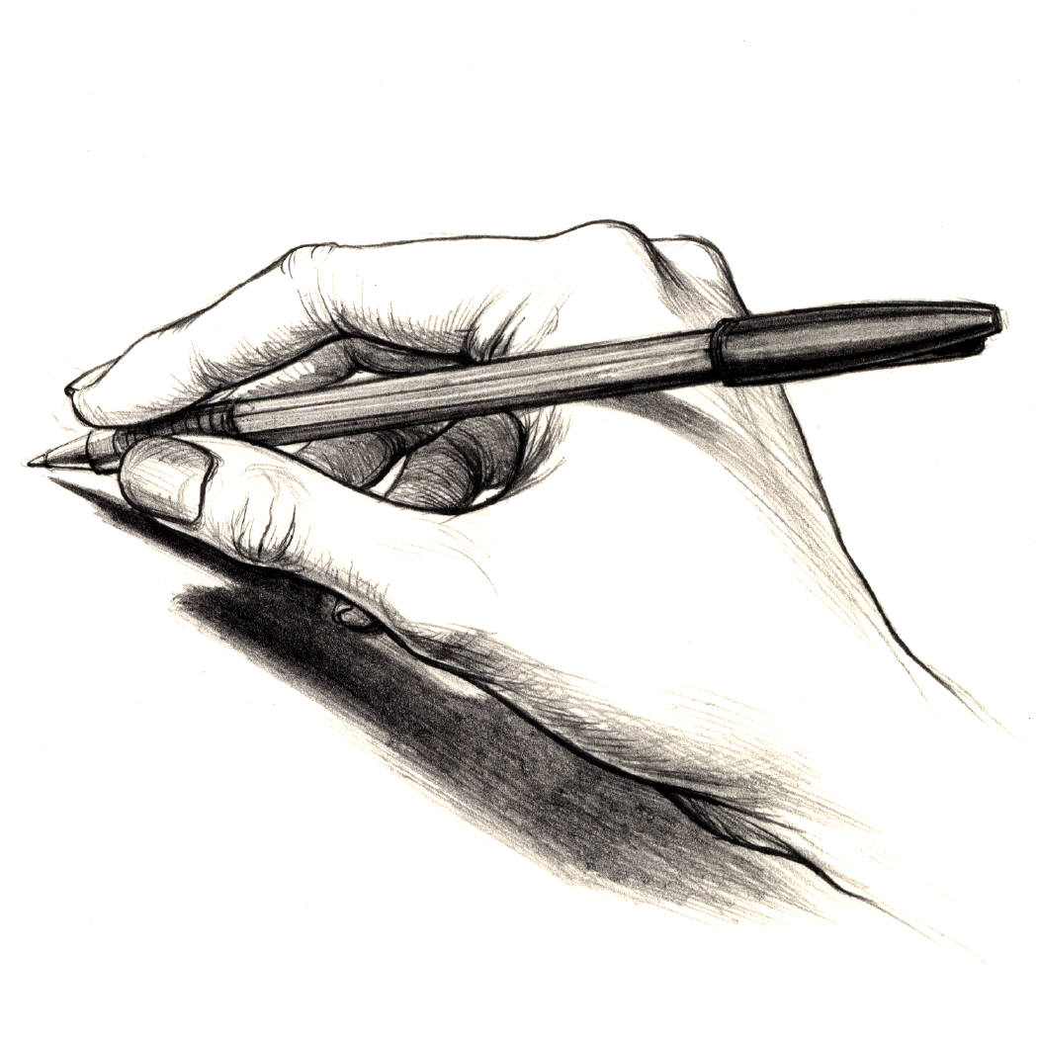
A Waugh, Editor, 2 Bramble Avenue, Newtownabbey, BT37 0XL
waugh_alan@hotmail.com

THE INSTRUCTOR
[Note: JE has been on holiday & also – due to pressure of space in this issue - we’ve chosen to go down memory lane with a reprint of a short piece on ANSWERING APPEALS from a previous one.]
The Umpires’ responses to any appeal must be based on a considered judgement and should never be hurried. If the appeal is upheld, the Umpire indicates his decision by raising the index finger above the head without any flourish or emphasis [no words are necessary!]. If the appeal is not upheld, the Umpire concerned should call “Not Out” in a clear, firm voice without any hint of prejudice, ostentation, apology or weakness.  An appeal is valid even if the ball is dead and remains so until the bowler commences his run-up for the next delivery, unless “Time” has been called. Do not be influenced by the volume or frequency of appeals, but treat each one on its merits considering carefully the visual and audible evidence before you. Remember the importance of consultation with your colleague if you feel he can assist on a point of fact [do not forget to call and signal “Dead Ball” beforehand], but, if any doubt remains, your decision should be “Not Out”. Although a batsman or bowler may react adversely to your decision in the heat of the moment, this should not necessarily be interpreted as dissent or abuse, and a degree of latitude should be permitted. However, no Umpire should permit a sustained abusive attitude to go unchecked. | Be firm and decisive, and, if necessary, take the appropriate action under Law 42. Avoid any discussion of your decisions during the game – offer any explanation in the clubhouse after the match!  [From Issue No 60, January 1999]  
NOTE: Before going to press, I discussed the choice of an article from history with Paddy and, in respect of this one, we considered Members attention should be drawn to the following point. As indicated above, this article was written 8 years ago. We now accept that a bowler will ask why when a player is given “Not Out”. To this end, we can and should, provided the question is posed in a reasonable manner, respond with a quiet and concise explanation – but never a debate. This is a man-management skill that Umpires must develop – it is part of Fieldcraft. The final sentence of the original article should, therefore, be deleted.
The Editor
SEPTEMBER QUIZ ANSWERS
1 [C] 6 [B]
2 [C] 7 [B] WINNER
3 [B] 8 [B] P L O’HARA
4 [A] 9 [B]
5 [B] 10 [A]
Cricket is my wife – DICKIE BIRD
10
Dear Editor  Congratulations on a unique 1st. production - the first Editor in our history to produce a September edition. Sadly however, this extra production was not in your contract, and you will not be paid for it.  I must also take issue with your comments on page 1. My four colleagues and I are adamant that we did not negotiate a 1-year contract, but a 5 -year one. Clearly you had consumed too much Bolly by the signing stage.  Congratulations also on a great report on your Bristol trip. I am pleased to reveal that the captains` reports have arrived and both you and Sam received excellent feedback from all four skippers. Very well done.  I am greatly puzzled about two items - one a letter and another an extract from the Cricket Europe forum, referring to "travelling distances". When there has been a problem with any matter concerning umpires, I am usually notified, and can then investigate the matter and take some appropriate action. However, in this case I have heard nothing. I always thought that "travelling distances" were to do with judging the direction of the ball after pitching, to adjudicate on LBW. Perhaps I will hear more during the winter.  What a brilliant and perceptive Fieldcraft article by "The Instructor" - J.E.McCall. I really hope that all our umpires read and digest all these monthly contributions. | They are always full of top quality advice. I hope that he (or we) will be able to produce them all in booklet form. It would make a wonderful "must read" for all our new umpires - indeed for all our umpires.  Oh dear - bad start with the "Puzzler" item. Perhaps you should leave that to the experts!  Now what about this for a quiz?  1. Which umpire brings his own cricket tea to some grounds?  2. Which ex umpire borrowed a light meter from another umpire for one day and then took three months to return it?  3. Which umpire was trying to find Eaton Park in Broughshane?  4. Which umpire was presented with a medal by the head of the British Civil Service, after giving an 8-ball over- in defiance of his colleague?  5. Which umpire thinks that God doesn’t know what happens in Spain?  6. Which umpire had no problem locating the Rose Bowl in Southampton, but can’t find The Green in Comber?  7. Which ’part time' umpire earned the largest single paid in advance match fee of 2007 and then had the match over by the lunch interval?  Remember, you are always being watched !!! Answers on a postcard to The Editor. PL O’Hara  Phew! Leave it to Paddy. By the way speaking of travelling distances and the like, anyone know how to get to Laurelvale? Might make a Q 8 above!
7

 Afternoon Post
Alan,  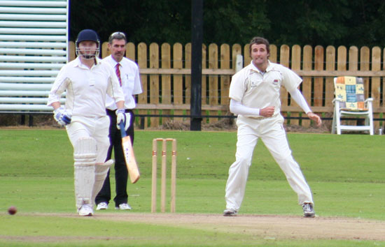  In action (2 words) OR inaction (1 word)? What would the editor mean by that????????  Mind you never a single there as shown by page 6's photo as James Hall was on the top of his game at square leg.  Great first effort. Noel McCarey  The editor is extremely pleased with your appreciation of his “first effort” but feels he must help you in your understanding of the English language. | “Inaction” (1 word) best describes the movement of the gentleman with the sunglasses on top of his head(?) in picture 1 – ie no movement at all. Whereas “in action” (2 words) captures splendidly the lightning movement to the side of the lithe, athletic umpire in picture 2.  Alan,  Congratulations on a fine first edition! Even more congrats on going electronic!! I will see that the e-edition gets prominent mention in our future editions so that we can share the valuable material.  Please note that our Newsletter is archived on our website (address at the end of each Newsletter).  Best wishes. Alan Tuffery  PS I am shocked to hear that you got a bribe- I got nuttin'!!  
  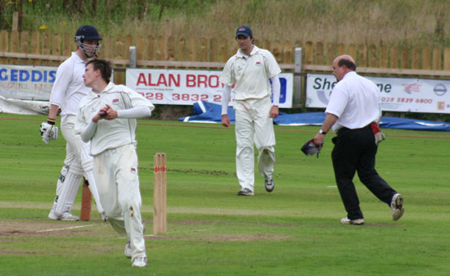

Cricket is basically baseball on valium – ROBIN WILLIAMS
8
From “The Ulster Cricketer” [with the kind permission of Peter Shields]  “When is all this umpire bashing going to end?  If anyone doesn’t appreciate the value of official umpires then play a game without them and see what happens. Love them or hate them, neutral umpires are the integrity of the sport and long gone are the days when captains carried that responsibility. In the cold calculating world of modern cricket it is dog eat dog most of the time, and that means many teams will do anything they can to win, including wiping the eye of the poor old umpire!  How farcical to call foul when the umpire makes a genuine mistake after you’ve spent the best part of the afternoon trying to con him with incessant appeals and at times blatant gamesmanship.  The umpire is everything in cricket, and his authority and integrity are beyond reproach, even when an error has been made. All umpires know the laws better than most of the players and they attempt to apply them fairly, but everyone makes mistakes. Look at last year’s World Cup final for evidence of genuine human error from the supposed best in the business.   | Every umpire is fallible but decisions whether good or bad, are integral parts of every cricket game. In the course of a season perhaps they even themselves out, but even if they don’t, they have to be accepted as part of the fabric of the game or anarchy rules.  Losers often blame umpires when their own mistakes are brushed under the carpet. Everyone remembers the ‘bad’ decision but how many players acknowledge the good decision? Yes, it is part of the game to appeal, but incessant appeals are intimidatory and calculating, and have no place in a game played in the right spirit.  It’s no secret that umpires are leaving the local game and it’s getting more and more difficult to recruit new white coats. A big part of this problem lies with the modern players who fail to respect the true value of an umpire and his role within the game. Of course there have been bad decisions and biased decisions down the years, but they have been part and parcel of cricket for a long time. What has never been part and parcel of cricket is the lack of respect and unless it is brought back into place, local cricket will self-destruct. That should not be allowed to happen.  Don’t kill the goose that lays the golden egg!  
This isn’t no time for playin’ the fool nor makin’ no sport: this is cricket!
EDWARD KAMAU BRATHWAITE
9

