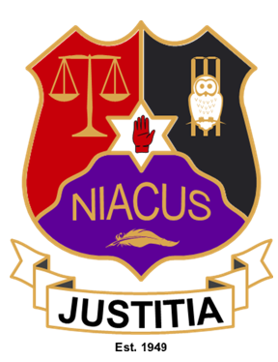

NIACUS Membership Application Form 2021

1.Applicant Information
Full Name: |  |  |  | Date:
 | Last | First | .

Address:

Street Address

 | Town |  | Post Code

Phone: |  | Email

Are you affiliated to any Cricket Club | YES | NO | If yes, which one?

Emergency Contact: |  | Phone: |  | Email

ECB ACO
Have you ever been a member of ECB ACO? |  | YES | NO
If yes, when:
If still a member of ECB ACO, Please confirm your membership number

Access NI

Have you ever held Access NI Clearance ? |  | YES | NO
If yes, when:

Disclaimer and Signature

Association notices and some information will be updated to NIACUS & NCU Websites. Members of NIACUS and any photographs taken may be used on the NIACUS or NCU website and publications in local newspapers. Please tick for consent of photographs to be used in this way. Yes [ ] No [ ]

The administrators of the NIACUS will only process the data requested for the general information of the Association. Under no circumstances will this data be passed on to commercial third parties. All this information is required so that, should the need arise, procedures may be carried out without any delays. In case of an accident or emergency, NIACUS will attempt to contact the persons listed in the Emergency Contact Details.

Membership and Association management data protection.
a) Processing of membership forms and payments.
b) Share data with Executive members to provide information about Association activities, membership renewals or invitation to social events
c) Sending information about promotions and offers from sponsors, sending an Association newsletter, sending information about selling kit, merchandise or fundraising.
d) Member’s details will be deleted/destroyed from Association documents after a period of 3 years if no longer affiliated to NIACUS.

*I have read and agree with the data protection and privacy regulations set by NIACUS and have ticked the consent box

I certify that my answers are true and complete to the best of my knowledge.
If this application leads to employment, I understand that false or misleading information in my application or interview may result in my release.

COMPLETED APPLICATIONS TO BE SENT TO: NIACUSMEMBERSHIP@GMAIL.COM
Signature: |  | Date:

For Internal Use Only
Date Received
Executive Member Proposing
Executive Member Seconding
Membership Approved
NIACUS Membership Number

