Northern Ireland Association of Cricket Umpires & Scorers



March 09 Issue No 135

President: Peter Lunney Chairman: Joe Moore Hon Secretary: Judith Hewitt Hon Treasurer: Michael Ross Editor: Alan Waugh

THIS MONTH’S CONTENTS
Page 1 | From the Chair
Page 2 | Editorial; Your Secretary Speaks; IACUS Chairman
Page 3 | IACUS Chairman (cont’d); Post Box; March Puzzler
Page 4 | Keith in India – Penultimate Episode
Page 5 | Fieldcraft by the Instructor - Boundaries
Page 6 | Ian’s Diary
Page 7 | 20 Years of The White Stick Trophy; Puzzler Answers

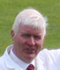
Photo: © Cricketireland.org

Hi all. Hope those of you who made it enjoyed the annual dinner. The nine active umpires and scorers who were there with the forty VPs and guests had a pleasant evening with lots of good banter, entertaining speakers and a very good meal. [You can gather, I take it, that sir was not very well pleased with the support – sorry, lack of support - of members, and trusts that conscience will not permit the same to occur for our 60th Anniversary Dinner next year!]

NOW, PLEASE TAKE CAREFUL NOTE OF THE FOLLOWING:-

BREAKING NEWS . . . . . . . . .



There are several changes that are of significance to us, as umpires for 2009. The most important is the NCU's re-writing of bye law (n) re: slow over rates.
Bye-Law (n) 2009:

"In 50-over fixtures to which umpires have been appointed, each team shall be in position to bowl the first ball of the last over within 185 minutes (inclusive of one drinks interval).
If a team fails to do so, play shall continue until the end of 50 overs (or the end of the innings if earlier) and the umpires shall award the batting team 6 penalty runs for each over not started within 185 minutes. The award shall be made at the end of the over during which the time limit was reached. In the second innings, if the penalty runs awarded to the side batting second takes its score past that of the side batting first, the match shall be over.
If an innings ends within 185 minutes, no penalties shall apply to it. The umpires shall have discretion to allow extra time for events beyond the control of the fielding side (e.g. injuries, lost balls, extra authorized drinks intervals). The decision of the umpires on all matters relating to this Bye law shall be final"
As you can see, the above does away with umpires reporting breaches of the permitted playing time - and the consequent fines system imposed by NCU in past seasons. But this new bye law is a very significant penalty on offending fielding teams.
EVERY NIACUS UMPIRE WILL HAVE TO BE COMFORTABLE WITH THE FAIR AND CORRECT IMPLEMENTATION OF THIS SIGNIFICANT CHANGE IN NCU CRICKET. IF YOU HAVE ANY CONCERNS OR DOUBTS AS TO HOW THIS SHOULD BE FAIRLY IMPLEMENTED, PLEASE ENSURE THAT YOU ATTEND OUR FINAL WINTER MONTHLY MEETING ON MONDAY 20TH APRIL WHERE THIS WILL BE DISCUSSED.

Given the importance of this new bye-law, we need to ensure a full house. There should be no hiding place for any umpire who doesn't bother to come in April, and then makes, perhaps a major error on match day.

[Ed. NOTE that April meeting is NOT the usual 2nd Monday due to Easter. The meeting will be on the 20th April.]

Your friend, Joe

PAGE ONE
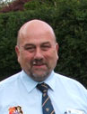
editorial

Photo: © Cricketireland.org


As reported elsewhere in previous editions this year’s Umpire Training Course was arranged for and has now been held on the weekend of Saturday and Sunday, 28th and 29th March at the St John’s Ambulance Headquarters at Knockbracken Healthcare Park
The course, attended by 16 students was the ECB ACO Level 1 course which is now the first step on the ladder for anyone wishing to become an umpire, especially anyone with future ambitions to umpire in European tournaments.
The participants all expressed their satisfaction with the course, presented so entertainingly by Keith & Trevor – especially the compactness of its weekend structure compared with the possibility of several dreary winter nights as previously the case – and at the end of the course had the opportunity to sit the Level 1 examination which is an aural/visual, multiple choice paper similar to the old GL6 examination.
Attending as an observer, I found the presentation interesting, the ECB training pack to be very colourful & useful and could recommend the course to not only all aspiring umpires but also to any umpire wishing to refresh their knowledge of law & practice – get your bookings in for next year for both Level 1 & 2! The premises were ideal as well as was the food at lunchtimes. Well done Keith and Trevor but next year Keith remember when the clocks go forward!
Alan


Your Secretary Speaks
Photo: © Cricketireland.org

about the
IACUS Annual Conference 2009

An overcast but brightening morning welcomed five dozen delegates to the eleventh conference, appropriately perhaps near parliament buildings. It was to be the first under the banner of the newly reconstituted Irish Association of Cricket Umpires & Scorers. It was, as usual, to prove an intense, hardworking day in a good spirit as umpires and scorers gathered to share their knowledge and experience for the improvement of their skills and the betterment of the game.
The “big picture” was a two hour presentation given by international colleague Louis Fourie, not on the basic laws and regulations of the game, but rather on how to manage the game, an area where his wealth of experience proved particularly beneficial in making this a successful and most enjoyable event. After an impressive lunch the ‘B’ movie proved to be as big an Oscar candidate as the main feature when Keith Smith entertained us with the highlights of his visit to India [the full text is printed elsewhere]. The delegates were also advised by Trevor Magee of the new ICC Europe training arrangements. The day’s activities finished with a discussion on achieving a new field uniform for umpires throughout the island for both proper cricket & thon coloured spectacle as well. There was also distinct social side to the occasion and some of the Leinster contingent, ably supported by a couple of dignitaries’ from NIACUS plus Munster’s Michael Hickey, made a convivial evening of it at the dining table in La Mon House, after the more serious business of the day.

Judith

IACUS Chairman's Report 2008

Irish Cricket Umpires & Scorers Association
Chairman: Murray Power - Hon Sec/Treas: Alan Waugh

Just over a year ago the ACUS, which had served the cause of umpiring & scoring with distinction since 1953, voted to merge with the ECB Officials’ Association and form a new Association of Cricket Officials under the auspices of ECB. This led to the winding-up a year ago of the Ireland Region of ACUS and the re-formation of IACUS.

That alone would have made 2008 a year of transition. On top of this, however, we have had the Irish Cricket Union morphing into Cricket Ireland, with entirely new management structures and several new staff, and ICC Europe taking responsibility for running the Europe Region of the new ECB ACO, in particular the roll-out of a wholly new range of training courses for umpires and scorers.

Your Association has been doing its best to secure the best outcomes from these changes for Irish umpires & scorers. We have made some worthwhile progress, but more remains to be done.

At the Irish level, the Association has – at last – been entrusted with making international & interprovincial appointments without being overseen by an ICU-chaired committee. In 2008 almost 40 umpire & over 40 scorer appointments were made [so far as I am aware, to the satisfaction of Cricket Ireland]. But aspects of the support arrangements by Cricket Ireland were less satisfactory.

PAGE TWO

The arrangements for paying umpires their daily allowances were embarrassingly shambolic, and the arrangements – or more often lack of arrangements – for providing umpires and scorers with advance copies of match regulations fell well short of what was required.

We have also not yet seen the implementation of a daily allowance for scorers on international duty – a commitment that has been in ICU strategic plans for almost a decade – although I have been assured that this is currently high on the agenda of the Cricket Ireland Finance Committee. There is also the question of Cricket Ireland field attire for umpires [and indeed scorers!] – something that seems to have dropped off the agenda in recent years. So your Executive will have plenty of topics to discuss with Cricket Ireland over the coming months.

At European level, our umpires continued to perform with distinction on ICC European Panels. It seemed that almost every time there was a European tournament last summer with Irish umpires, at least one of them was selected to stand in the final. I know that this was a great source of pride and satisfaction to everyone here – as well as to the wider Irish cricket family. In this context, I’d particularly like to congratulate Mark on his recent elevation to the reserve list of the ICC Associate & Affiliate Umpire Panel and Louis on his promotion to join Mark, Trevor & Charlie on the ICC Europe Elite Panel. Just as our players aspire to be the leading Associates in Europe [& thus probably in the world], we as an Association should, I believe, have similar ambition in relation to the primacy of our umpires and, indeed, our scorers when the promised ICC Europe Scorer Panel is launched in the coming months. A welcome indication of our existing standing was Paddy’s appointment last year as the umpiring representative on the European Cricket Committee.

Congratulations, Paddy – we can be confident that you won’t shirk from telling the Committee what it needs to know, even when it may find the message less than comfortable!

On the training front, the new arrangements for the Europe Region have been almost painfully slow in taking shape. It has been more than a little frustrating to see the ECB ACO running Level 1 courses – and indeed pilot Level 2 courses – for umpires & scorers in each of the English regions without any of the same happening in Europe. Recently, however, there has been a significant step forward with the first Tutor Training weekend at Lord’s. We sent five tutors over and it was terrific to see all five – Alan Tuffery, Peter Thew, David Caldwell, Keith Smith & Trevor Magee – being immediately accredited to deliver the new Level 1 Course. Hopefully we’ll also have Level 2 Courses available by next winter. The silence from ICC Europe about courses for scorers has however been pretty deafening, and I feel that this is an area where we’ll need to keep up pressure in order to encourage some progress.

So that was 2008. A busy and challenging year but one in which I believe the reputation of the Association and its members – domestically & internationally – has continued to grow. I should like, on your behalf, to thank our Hon Secretary/Treasurer, Alan

Waugh, for all his hard work behind the scenes, and the members of the Executive & Appointments Committees for their valuable contributions. 2009 will bring fresh challenges for us all, but I’m confident that we have the people and the ambition to meet them successfully. Thank you all.
Murray

 Post Box 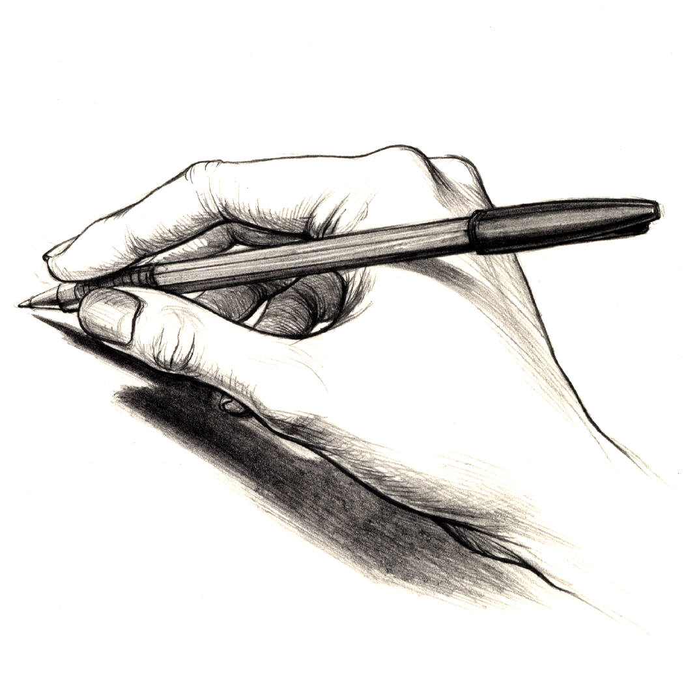
A Waugh, Editor, 2 Bramble Avenue,
Newtownabbey, BT37 0XL
waugh_alan@hotmail.com

Dear Editor  Following this month's meeting, on the 9th March, and the presentation on Umpire grading, I am writing to offer one or two observations from the standpoint of a relatively "novice" umpire who is anticipating his third season standing. After listening to a detailed presentation of a discussion document which was well prepared, and then to an equally detailed reply from the grading convenor, I was left thinking of the old but true saying, “if it’s not broken, don’t fix it.  Of the 3 categories of assessment outlined, one has been abandoned, namely the colleague reports, one is totally impractical, that is boundary assessors, and so we are left with captains’ reports, and that is exactly the basis currently used for grading, together with agreed qualifications. While it is obvious that the captains’ reports are not perfect and that many captains clearly don’t give their reports sufficient attention, what are the options? Listening to the debate, there is no clear alternative.  Surely what we must focus on is adapting and fine tuning the current system, which on the whole seems to be fairly satisfactory. For instance, the suggestion to shorten the captains’ report forms and make the questions more relevant is an important step forward. Perhaps clubs could be encouraged to have captains return forms immediately after a match, and, in turn, the NCU encouraged to get the reports to the grading convenor quickly. If captains want an improved umpiring standard, then they must be prepared to play their part in spending 15 minutes after a game properly considering an umpire's performance. That, if done, should greatly assist the grading committee in their difficult and time consuming task.    March Puzzler  No. 1 On the fourth ball of an over, the striker is deliberately obstructed by the bowler as he is setting off for a second run, turning at the bowler’s end. The bowler then properly puts down the bowler’s wicket with the striker out of his ground and appeals.  - How do you answer the appeal?  - How many runs have been scored?  - Who faces the next delivery?  - How many balls are left in the over? | Perhaps one other more controversial suggestion might be to structure an appeal system for any umpire who feels unfairly graded. Allow an umpire recourse to formally appeal a grading, at which he might have access to more sensitive information on how his grading was determined.  This way any umpire  "unhappy" with his grading would then feel able to be heard and defend his position. I would suspect this system in most instances would result in confirmation of the original grading but it might remove any sense of unfairness felt by an umpire against the grading committee's decision.  Debate is healthy, and demonstrates our democratic principles in NIACUS but  change for changes' sake is seldom successful.  Louis Arneill    PAGE THREE  No. 2 The bowler stops in his run-up just before entering his delivery stride, and throws the ball at the non-striker’s wicket. The non-striker is out of his ground, but the ball misses the stumps and runs out towards square leg. What action are you required to take?    ANSWERS LATER IN THIS EDITION


Indian Cricket League
An Experience of a Lifetime
by Keith Smith

PENULTIMATE EPISODE
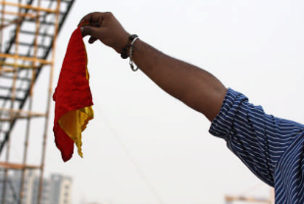
Over the next seven days I officiated five times, four on the field and once in the box. I said earlier that umpiring televised cricket was different. We were about to see another side to it that had not emerged before. Tony Greig informed us that the TV Company had to repay US$170,000 to advertisers because their adverts were being cut short between overs and when a wicket had fallen. What was to happen for the remainder of the tournament was that, at the end of an over or the fall of a wicket, a crew member would stand outside the commentary box holding up a flag (it was more like a red handkerchief) and the bowler’s end umpire must not allow play to recommence until the flag came down. Forty-five seconds between overs and sixty seconds at the fall of a wicket does not seem long but, when you consider that the adverts do not start until any replays have been shown you can appreciate how much time is wasted during a forty over match. Both the players and the crowd became frustrated when batsman and bowler were ready but the umpire was still holding up play. Eventually the guy with the flag was replaced by a light but the times remained the same.

My on-field activities were again straightforward during the week in Delhi. Four matches, further challenges and every one rejected by my colleagues upstairs. At this stage in the tournament I was the only umpire who had not had a decision overturned. I again had the Sunday afternoon match along with Allan Jones. It was nothing to write home about although Joy had the following published on our internet blog. “The only real excitement of the afternoon for Jules and me was when Keith was pole-axed by Sarabjit Singh, the batsman who was running to Bowler’s End, head down, hitting Keith in the chest with his helmet. They both went down like nine-pins but thankfully were OK. Keith is still bruised and sore but he’ll survive.”
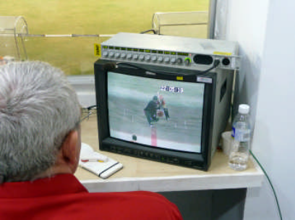
The night I was third umpire I was able to get Joy to accompany me in the box. This was a new experience for her and she found it interesting. I had to overturn one of Allan’s decisions when he gave an LBW appeal in favour of the batsman and this brings an interesting discussion point into the equation. As umpires we are always (quite rightly) taught that, if the batsman is well forward when the interception occurs, there must be an element of doubt and the batsman should be given ‘not out’. If, as happened here, that decision is challenged, the only view the third umpire is given is the front one and, providing the ball pitched in line and would have gone on to hit the wicket, the distance the batsman is from the wicket is irrelevant and he is given ‘out’. This happened to me later in the tournament.

I did manage two days off during the week. On the first one we took a car into the city, heading for the Red Fort. Amazingly (!) the car park is a considerable distance from the fort and our only means of getting anywhere near was either on foot or by bicycle rickshaw. We opted for the latter as it was a new experience and what an experience it proved to be. Four Indians, four rickshaws and four of us – yes, one each. One guy appeared to be in charge and, having got us to the fort said they would await our return. We thought we had seen the last of them until we realised they had not been paid. Sure enough, when we emerged from the fort, they emerged from the chaos of traffic. It was agreed that they would take us around the sights of Old Delhi, even to places that cars could not get into. It was an interesting few hours, albeit quite hair-raising whilst on the main thoroughfare.

Ranmore’s wife, Jenny, was also with us for a week so a little negotiation with our colleagues allowed him, Dave Brandon and me to have a day off to allow all six of us to go sightseeing together. Naturally our thoughts were Agra and the Taj Mahal. We tried to book on the train, again to broaden the experience, but found that we could not get a train back until 3 November and we were going on 29 October. However, negotiations with our transport manager were successful and he arranged for a luxury mini-bus to take us on the five-hour trip. It was a long journey and most of us (except Joy!) slept some of the time but we did take in a lot of the scenery and many fascinating sights once we got out of the hustle and bustle and into the countryside. One interesting sight was of a number of large, flat, round discs that were propped and piled up on the central reservation of the carriageway. We discovered that they were animal dung that had been shaped by hand and was drying out so that it could be used for building or fuel. Another was of a guy riding down the main road on his elephant. There were also the cows in the middle of the road that had to be negotiated because they are a sacred animal.

PAGE FOUR

Having stopped off to visit Agra Fort, the final leg of our trip to the Taj was by camel cart. I was always told that camels smelled but Sultan must have been the exception to the rule. I declined the invitation to get up and ride on his back though, preferring to stay on the cart. Now one of the New Wonders of the World, the Taj Mahal really is a magnificent structure and seeing it was the highlight of my off-duty time. I would have loved to have been there longer in order to see the colour changes as the sun went down.

The week in Delhi passed far too quickly and it was soon time for us to move to Chandigarh and for Joy to return home. We said our ‘good-byes’ at 05:00 as we were booked onto a charter flight along with the TV crew and some of the teams. Joy was left alone in the hotel as her flight was not until later that morning. Thankfully our transport manager came up trumps again and escorted her safely to the airport.

Chandigarh seemed rather more civilised than the other places we had stayed in. It is much further north and quite close to the Himalayas, thus much cooler in the evening. The roads are more like tree lined avenues and the traffic stops when the lights are showing red! One could even walk down the road without the risk of being mowed down by traffic on the pavement. It appeared to be a more affluent area although there were still some women and children begging. Unlike Ahmedabad you could buy alcohol and I managed to get a bottle of whisky for 150 rupees and two match tickets (that’s £2 in real money!). A bottle of wine was 600 rupees.

The ground at Chandigarh was very pleasant. It was the smallest of all the grounds used and thus drew in the smallest crowd, but they were still fanatical about their cricket. I had a ‘double header’ on the Sunday - third umpire for the afternoon match and in the middle in the evening. I have been told on many occasions that all umpires will have a nightmare match at some time or other . . . . . . .! ! !
Keith
[Nightmare? Wait & see! Ed.] [to be continued]

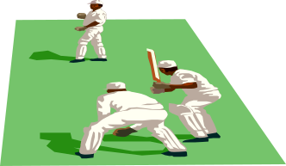
FIELDCRAFT

by the Instructor BOUNDARIES

The boundary is the perimeter of the field of play and is therefore the part of the ‘arena’ which is furthest away for the umpires ‘in the middle’. For this reason it is important that the umpires carry out a thorough check of the boundary, and the way it is marked, during their pre-match inspection. Law 19 requires “wherever practicable the boundary shall be marked by means of a white line or a rope laid along the ground”. However, there are other acceptable methods of marking the boundary e.g. a fence or board and an imaginary line between

flags. Whatever type of boundary exists there must be a clear and unambiguous definition of the ‘boundary edge’.

The boundary edge is the inside edge of the white line or the rope. In the latter case, it is the “line formed by the innermost points of the rope along its length”. If a fence forms part of the boundary, the boundary edge is defined as the base line of the fence. In some cases, when no painted lines or rope are available, flags are used to mark the boundary and in this situation the boundary is the imaginary straight line joining these markers. Obviously this adds to the umpires’ difficulties in determining a boundary score from the ‘middle’. In recreational matches where these circumstances are more likely to occur, the umpire may have to rely on the honesty of the fielder. Flags are also used in conjunction with a line or rope boundary and it is important that the umpires, during their inspection, make sure that these markers are placed behind the boundary edge i.e. beyond the inside edge of the line or outside the rope.

On some cricket grounds there are obstacles within the field of play. Some of these may be permanent, such as a tree or overhead wires. Others may be mobile, for example a dog or a spectator running on to the field of play and coming in contact with the ball. None of these ‘obstructions’ are to be regarded as a boundary unless the umpires decide so before the toss. Local custom may decree that a permanent obstacle is to be accepted as a boundary and this ruling will supersede the Laws of cricket. With all these potential uncertainties, it is essential that the umpires agree the boundary of the field of play and how they will deal with any unusual situation with both captains before the toss.

Two other potential problems for umpires, in relation to boundaries, are overhanging trees and sight-screens. In the case of the former, or where shrubs encroach on to the playing area, if the ball touches any part of the tree or shrub then it is deemed to have ‘touched the boundary’. Law 19.3 makes it quite clear that this constitutes contact with an “object in contact with the ground outside the boundary edge”. Law 19.1 states that “the boundary shall be agreed so that no part of any sight-screen is within the field of play”. This means that if the sight-screen structure is within, or partly within, the ‘playing area’, then the ‘boundary line’ must be drawn round it. This part of the boundary marking must allow for the movement of the screen as required during the game. Again this forms a crucial part of the pre-match inspection by the umpires.

During play, if the boundary is disturbed, it should, if possible, be restored to its original position as soon as the ball is dead. Not all grounds on which cricket matches are played are completely flat and the bowler's end umpire may have difficulty seeing the critical part of the boundary when the ball is played into the outfield. In some such cases the striker’s end umpire may have a clearer view of the situation and ‘consultation’ may provide the necessary information, a nod or simple signal may be all that is required. The boundary also has an important role to play for the scorers. A batsman’s innings starts when “he first steps on to the field of play” i.e. when he crosses the boundary. PAGE FIVE

This does not apply to the opening batsmen and to any new batsman coming in at the resumption of play after an interval or interruption when “Time” has been called. In these cases his innings starts on the call of “Play”.
Most of the pitfalls for umpires concerning boundaries can be avoided if they carry out a thorough inspection of the ground and they have a meaningful meeting with both captains before the toss.


The Instructor

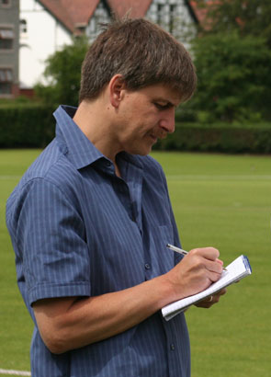
Ian's Diary 08
Photo: © John Boomer by Ian Callender

Week ending August 22
This won‘t take long! Not a ball was bowled in the NCU this week as, would be deciding some matches this afternoon. His reaction was a very revealing: “Oh, no! “ It subsequently transpired that this was just one of four Section Two games when bowlers bowled the “wrong number” of overs in Section Two games with five teams and at least five different umpires involved. Not good enough!
Ireland finished the international summer this week with thee ODI’s against Kenya at Stormont. At least that was the plan but nothing much went to plan in August 2008. Sunday’s first game was played to a conclusion, the bowlers dominating as 19 wickets fell for 263 runs, Andre Botha taking four of them and Kenya were bowled out for 115 in a match which marked the first home appearance in an Ireland shirt of big Boyd Rankin, five years after one of Ireland’s World Cup heroes made his debut. Monday’s game also started on time but, eight overs later, with Ireland 18 for two, the latest downpour hit Stormont and two hours later, ominously, groundsman Philip McCormick not only predicted an abandoned game but no play on Wednesday! Apparently the rain had bounced off the main covers and flooded the end of the bowlers’ run-ups before the big sheeting could make it to the middle.
The second game was duly abandoned and despite a dry Wednesday, the final ODI was also abandoned at 11am, 15 minutes after the scheduled start. Many questions were asked but this is not the place for the answers.
Week ending September 5
To Shaw’s Bridge on Saturday and, guess what, there was cricket going on when I arrived. I was only 25 minutes late but Instonians were already seven for three and that was to become eight for four as the North Down bowlers enjoyed themselves on the upper ground, which was not really fit for a Premier League game but, with eight games to play in a month, it really was a case of needs must. Instonians eventually made 86 in 43 overs and North Down won the match by seven wickets in the 38th over! It wasn’t the lowest scoring game of the day. Middle Road, Carrick, must have been even lower and slower. Lisburn were bowled out for 98 but they then shot out the home side for 53.
The week ended with the Irish Cup final at Strabane, since their move up Park Road now a very impressive set-up with plenty of seating for spectators and an excellent clubhouse. In this summer there was little chance of the club highlight being completed in one day - and it wasn’t. Donemana enjoyed the better of Friday, reducing North County to 106 for five in 32 overs but the holders had still to bowl!
Week ending September 12
North County won the Irish Cup by 53 runs. An eighth wicket stand of 46 got Donemana up to 165 for nine in their 50 overs, after heroic work by the Strabane ground staff to get the ground ready for an 11.15am resumption, and, sure enough, the NC bowlers did the rest. It was their fifth Irish Cup success in eight years and, fittingly, they became the first team to retain the trophy in the 27-year history of the competition.
Yet again, the NCU grounds could not cope with the weather, because of the, now, August/September rains, and only two matches were played all weekend. Inevitably one was at Comber, although even there only a 21 overs match was possible. I went to Stormont where Lisburn did not even manage 98 runs this week. They slumped to 49 for seven and were bowled out for 81. Civil Service North got the runs in 15.1 overs and then heard that North Down scored 60 in 26 balls to beat Derriaghy by 10 wickets. The title race is set to go to the wire. Each has six games to play and they are still deadlocked - and two of the games are against each other! Presumably Derriaghy are saving themselves for matches they think they can win as they fight Carrick and CIYMS to beat the drop.
Ian

Sixty-two players have represented NIACUS with Paddy O’Hara (14) and James F McCall (12) being most capped.
Unsurprisingly, there have been lots of “one-cap wonders” – the most high profile being Ian Houston who was selected and made captain when O’Hara was controversially sacked in 2003. He led us to a resounding 99 run defeat at Comber. Opening the batting he made 3 from eleven balls before being clean bowled – he never played again!
PAGE SIX
In stark contrast, LCUSA’s most memorable “one-cap wonder” was a gentleman called Graham Guthrie who played at Lisburn in 1996. Chasing our respectable 140 for 7, he smashed 100* off 19 overs with 13 fours and 5 sixes. Whatever happened to his umpiring career?
Derek Adams holds two unique records. He is the only player to have played for both sides. He guested for LCUSA at Clontarf in 1989 and made 35 batting at No 4 – thus ensuring that we lost the match by 2 wickets. Secondly, he is the only player from either side to have been selected Man of the Match twice – in 1991 and 1993.
1999 was the only year that saw NW umpires involved. George Brolly and David Caldwell turned out for Leinster at Laurelvale, with David winning the Champagne Moment Award with a superb diving catch to dismiss John Boomer – the NIACUS players were delighted that he clung on to it because John had batted 17 minutes for 1 run!!
John and Neal Boomer are the only father and son combination to have been selected in the “Stick” Series. Daddy did win an M-o-M award (in 1992) – something the boy never managed. The next closest was George Wilson playing at The Mall in 1994 and a very young Gary fielding sub for a while.
NIACUS has been represented by two Irish Internationals – ‘keeper Walter Fawcett and all-rounder Ian Johnston, while the best LCUSA can boast are two Irish Senior Cup Winners – current skipper John Andrews and another “one-cap wonder”, Adrian Murphy.
We’ve had four half centuries: Alan Neill leading the way with 71* and 56; Alex Adams 58; and Paddy O’Hara 53. Also two “five-fors” – Derek Adams 5 for 26 and Billy Ross 5 for 53. Cyril Vennard distinguished himself with the most miserly bowling figures in “Stick” history. At Rathmines in 2000 he returned 4-4-0-3.
“Champagne Moments” were introduced in 1992, with catches figuring largely in the selections.
- Arthur Thompson: 1-handed catch at mid-on of which his grandchildren got hearing
- Walter Fawcett: ankle-high slip catch
- Alan Waugh: forward-diving gully catch (in marked contrast to his recent efforts!)
- Paddy O’Hara: parried catch at mid-wicket
- JF McCall: slip catch
- Alan Neill: 1-handed leaping catch at square leg
It was in 2000 that James E McCall broke the mould winning with a cricket stroke – described in the book as “a perfect cover drive that streaked to the boundary”!
Strangely, in 2007, the award changed from a champagne moment to a champagne four minutes when Joe Moore won it for taking two wickets in his only over. More of a miracle really!
The original White Stick was lost by Leinster’s Alan Tuffery – he left it in a pub one night and completely forgot about it. Months later the pub burnt down and the Stick with it. All that could be salvaged from the remains was the golden duck’s head. Leinster had a perfect replica built using the original salvaged piece. It has been rumoured that he head was hollowed out and the old stick’s ashes are sealed inside – but we cannot confirm this.
The only year there was no match was in 1998 when it was cancelled as a mark of respect for Richard Simpson who had tragically just lost his teenage daughter.
NIACUS now trails 8-11 in the series, the widest gap in the history of the competition. Recently, there was a protest outside Chairman Joe Moore’s house in Carnmoney with placard wielding umpires chanting, “What do we want? A winning team! When do we want it! NOW !!!”
Somebody has suggested bringing Ian Houston back – that is how desperate we are!
WHITE STICK HISTORIAN
March Puzzler Answers

No 1

I Not Out (The Umpire will Call & Signal Dead Ball)
II 7 runs (5 Penalty Runs + 1 completed + 1 in progress whether crossed or not)
III The Batsmen at the wicket decide
IV 3 Balls. This delivery does not count as one in the over.

No 2

Call & Signal Dead Ball as soon as possible after the ball misses the wicket.

N.B.

Date of Next Meeting
Monday 20th April

Any problems in e-mail delivery let me know.
PAGE SEVEN
aw08

