Northern Ireland Association of Cricket Umpires & Scorers



February 09 Issue No 133

President: Peter Lunney Chairman: Joe Moore Hon Secretary: Judith Hewitt Hon Treasurer: Michael Ross Editor: Alan Waugh

THIS MONTH’S CONTENTS
Page 1 | From the Chair; Editorial [NIACUS Names in the News]
Page 2 | Post Box; ICL: Experience of a Lifetime by Keith Smith
Page 3 | More from Keith
Page 4 | Fieldcraft: Coping with Pressure; Ian’s Diary
Page 5 | More in the Diary; February Puzzler
Page 6 | Answers Dec/Jan Puzzler; Judith on the Conference
Page 7 | NIACUS Umpire Training 2009; And finally . . .

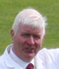
Photo: © Cricketireland.org

Christmas and the New Year have come and gone and a lot of hard work is required by your Committee in the coming weeks. The All Ireland Conference in February and the Annual Dinner [Friday 27th March at Newforge] are the main items but a host of smaller items have also to be dealt with. I’m sure none of the Committee would take offence if I mention the extremely professional job that Judith is doing for the Association. At times she must imagine that her daytime job has extended to Monday nights!!

I make no apology for returning to my old chestnut – ATTENDANCE! – or lack of it as the case may be. Reading notes in THE FOLLOW-ON & TOM SMITH are fair enough, but actual participation in a discussion is in many ways more beneficial, and those of you who missed the January meeting are now minus the positive experience of a power-point presentation & debate on The Laws & Competition Regulations given by your esteemed Editor.

The new season is just around the corner – despite the weather – and I’m sure that each member is now looking at what new equipment is required. Seagull will help but he must have orders before the end of the month. [NOTE: The ad in the last edition was incorrect. The cheaply available fleece is XXL & the shirts 18” & 18 ½ “.]

Get your name to Judith as soon as possible for attendance at the Conference. In order to facilitate catering & administrative arrangements it is preferable to book your place for the day & give notice of your intention to attend – not just turn up though we will turn no-one away! To this end, please contact Judith or any other member of the Committee on/at or before the February NIACUS meeting & [as you will read later] NO LATER than 15th.
Your friend

Joe
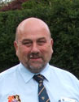
editorial

Photo: © Cricketireland.org

NIACUS NAMES IN THE NEWS

The Association’s heartiest congratulations are due to Vice-President Dixon Rose who was awarded the M.B.E. in the 2009 New Year’s Honours list for voluntary services to Northern Ireland sport. Another Vice-President Billy Ross has achieved a fine 80 not out on 19th January. Michael Ross our new Honorary Treasurer is off to India with the Grasshoppers as player/umpire. [I hope he is not taking all our money with him!]

Talking of India, Keith Smith who has found fame and fortune [and a cracked skull!] umpiring in the rebel Indian Cricket League at the end of 2008 can be heard relating some of his experiences [which are now being serialized in THE FOLLOW-ON] at our ICUSA conference at Stormont on Saturday 21 February. As pointed out elsewhere in this edition, this is a "not to be missed event" for all our members. Please get your booking in to Judith Hewitt ASAP. [See “Your Secretary Speaks”]. Also, at a recent training seminar at Lord`s, Trevor Magee and Keith Smith have qualified as ECB Level 2 accredited tutors. This will ensure continuity of training for our Association, following the demise of ACU&S. NIACUS can now deliver training via this body and/or ICUS.

John Boomer another Vice-President, former International umpire, former Editor of our Follow On, photographer extraordinaire [the list goes on!] has been elevated to the ICC Europe Elite Referee Panel for 2009. Also in Europe, Mark Hawthorne and globe trotting Trevor Magee are still on the ICC European Elite Umpire panel - with Alan Neill and Keith Smith on the ICC European Umpire panel. Mark has also been placed on the reserve list for the ICC Associate & Affiliate International Umpire panel. Bubbling under is Noel McCarey who is on the Probationer list for the ICC European Umpire panel - with the prospect of his elevation in 2010. And finally, Paddy O`Hara, an ICC Europe umpire advisor, has been elected to serve on the European Cricket Committee. Congrats to all of you from all of us!
Alan

APOLOGY: Ivan Anderson’s name was mistakenly omitted from the Vice-Presidents’ List last month. I’m very sorry for any embarrassment or upset this may have caused.
PAGE ONE
 Post Box 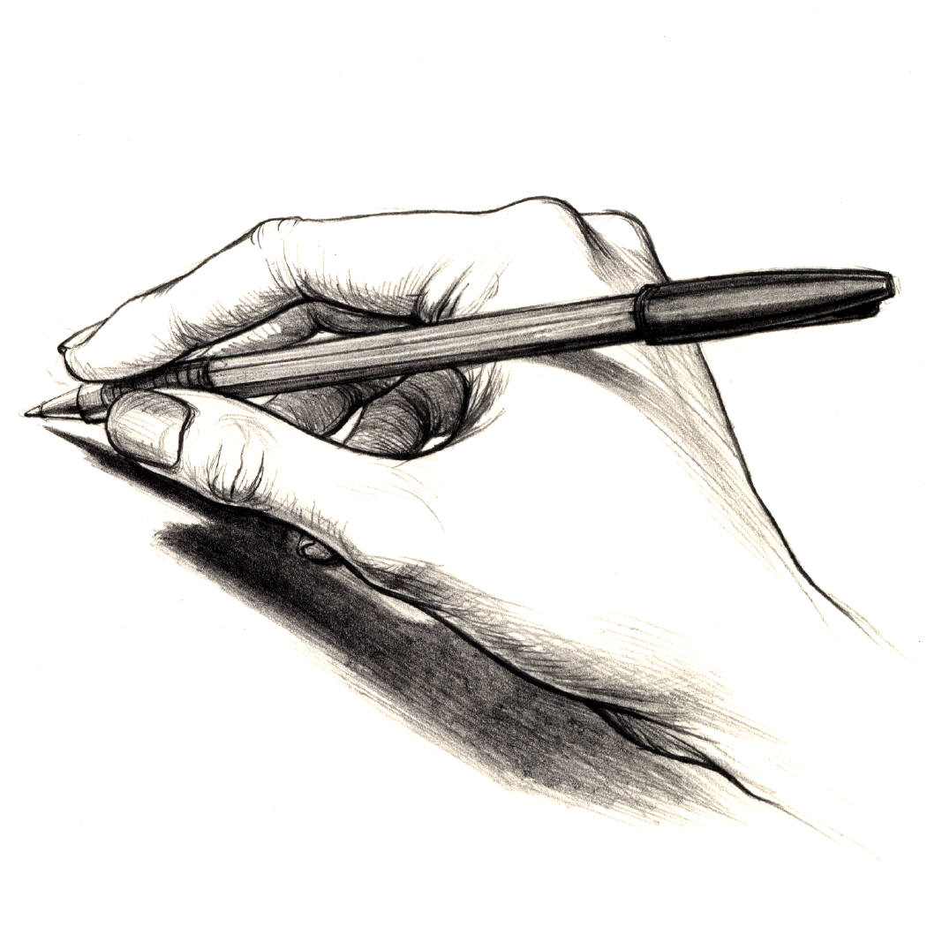
A Waugh, Editor, 2 Bramble Avenue,
Newtownabbey, BT37 0XL
waugh_alan@hotmail.com

Dear Editor,  As someone who is an avid reader of your most excellent (and, I understand) voluntarily produced magazine, may I share your frustration at the apathy shown by your readership, in the absence of “Letters to the Editor”? May I start to redress the balance by writing to you, as someone who is not involved at the coal face, but as a person who has a keen interest in umpiring – particularly in Northern Ireland – and who follows the fortunes of our wonderful umpires who provide such a superb service to NCU and NWCU league and cup cricket?  It is with considerable sadness that I note the dreadful performances of your White Stick team over the last several seasons. It seems to me – as an outsider – that the captain should be not only relegated to the ranks, but left out of the team entirely. Where is the inspirational leadership that gave NIACUS such dominance in the latter part of the last century?  However, having given the matter much thought, I have decided to write on a different topic altogether: Women and cricket – do they go together?  I have watched with growing concern, the inexorable invasion of the female of the species into our beautiful game. NIACUS was bossed for years by Joy Muir-Smith, and having got rid of her, is now being bullied and harangued by new Hon. Sec., Judith Hewitt! How did these women get into positions of influence and authority, here and in Euro Land, where Siobhan McBennett has become the Joy Muir of LCU&SA – the last bastion of “men only”, where old curmudgeons like Hogan, Daultrey, Heavey, Keegan & Carpenter and the like, fought desperately to keep women – or as they called them, scorers - out of their Association?  Where did it all go wrong boys? Look at you now! Women umpires, for God’s sake! Aoife Sheridan apparently gets all the plum matches round Dublin and – shock horror – the Free State has been invaded by another “she” – an ICC Europe Panel member no less, by the name of Ingebord Bevers, from some little known cricketing area in Europe. | Perhaps ART has answers? Anyhow, I suppose I shouldn’t be disrespectful. Welcome to Ireland “dutchess”. What is the betting that those two will get next year’s Bob Kerr Irish Cup final? And another thing, those really are silly first names. What self-respecting Ulsterman could pronounce those?  N.I. umpires are not exempt from this domination by “the Amazons”. NIACUS, run by “Mistress Judith”, has discovered that the wife of one of its leading umpires has only gone and got herself pregnant. And when is the sprog due? Smack bang in the middle of the cricket season – JUNE. How devious is that?! Another thing – I see they have two women as Vice Presidents. What could they possibly know about cricket? Were they famous tea ladies?  The North West need not be overly smug. After a lifetime of umpire appointments made by real men like Harry Henderson and Robin Glenn, what have they got for 2009? MARY McELWEE!! OK, so hubby Charles is supposed to be helping her, but what chance has he got? If he doesn’t go to Tesco’s on a Friday night, he can expect to spend the next day at Crindle II v Bond’s Glen III.  These creatures are now playing cricket as well. But is it worth their effort? I recently read the following:  1. “In a women’s match against South Africa, Bermuda were dismissed for 13 and then their opening bowler sent down nine Wides and a No Ball in her first over before being hit for four. There were five scoring shots in the entire match”.  2. “A 40 – over women’s game between Trinidad & Tobago and Canada featured 129 Wides, 81 of them by Trinidad & Tobago, who won”.  Have I made my point? Keep them in their box – the scorebox.  A keen cricket watcher.  In sport,  A.N. O`Nymous  [Ed. Name & address supplied. Honest!]


Indian Cricket League
An Experience of a Lifetime
by Keith Smith

PART ONE
Regular readers of The Follow-On will already have read how a telephone call at the end of September changed the whole structure of my lifestyle for the months of October and November. It took a little while to sink in but yes, I was off to India, a country that I had always wanted to visit. Not only that, but I was going there to do something that I love – umpiring cricket.

The journey started with a three-leg flight; Belfast to Heathrow, Heathrow to Mumbai and Mumbai to Hyderabad. It was the first time that I had travelled ‘business class’ and that in itself was an experience. I met up with Allan Jones at Heathrow and we were able to enjoy each other’s company for the long flight and the four-hour wait in Mumbai.

Allan retired from the First Class umpire panel last September and this was to be his first experience of the ICL so at least I was not alone in that respect. My other colleagues were Dave Orchard, recently retired from the International Panel (first ICL tournament), Shakeel Kahn from Pakistan, another former Test Match umpire, Ranmore Martinesz, First Class umpire from Sri Lanka and lastly my good friend Dave Brandon from Wales. Shakeel, Ranmore and Dave Brandon had done previous ICL tournaments so were not phased when administrative arrangements went somewhat astray!

My first steps on Indian soil were in Mumbai where the temperature was warm but the rain was coming down like stair rods. Fortunately this was only at the airport and by the time we reached Hyderabad the rain had ceased, although we did have some showers over the next few days. On arrival in Hyderabad it soon became clear that the driving in India bore no resemblance to driving at home.

A three lane road would carry four or five lanes of traffic. Cars coming onto major roads from minor ones have the right of way, as does traffic entering a roundabout. Traffic lights are largely ignored and it can be difficult to establish whether they drive on the left or the right! We had to spend the next ten days in Hyderabad.

We had two days to acclimatize ourselves before the tournament commenced and it was during this time that we came to realise that the organization was different to that we were accustomed to. We had a meeting with the tournament organisers and TV commentary team, namely Kiran More, tournament director along with Tony Greig and Dean Jones, all three being on the ICL executive board. We discussed the playing regulations at length, especially the ‘challenge’ system whereby each team was allowed two challenges per innings against an umpire’s decision. No-one can say that the ICL is not innovative.

PAGE TWO
One regulation they wanted to bring in was a nine-run boundary allowance for shots that cleared the rope and travelled more than ninety yards! We soon got that stopped.

We also required kitting out and were taken to the sponsor’s retail outfit for trousers. That was a laugh – no-one appears to stock ready made trousers larger than a thirty-eight inch waist. After trundling around five or six retailers I finished up having trousers made for me. They were delivered to the stadium twenty minutes before my first match, the second night of the tournament. Why the organizers did not tell us we were to wear black trousers I’ll never know. We could all have taken our own with us.

The night before the tournament began we were entertained at a buffet reception where we had the opportunity to meet with the players informally. It was here that I was introduced to Kapil Dev for the first time as well as meeting many players whom I had previously only ever seen on television. The opening ceremony had all the razzmatazz that one would expect from a high profile tournament. Fireworks, music, dancers and an acrobat on a balloon. Every team lined up along with the team mascot that was present at the ground each time the team played.

I was not in action on the first night but took the opportunity of walking out before the match to savour the atmosphere of such a large crowd. I spent the evening in the third umpire’s box acquainting myself with the technology and secretly hoping that all sorts of things would occur in order that I would know what to do if it happened when I was third umpire. As it happened it was a quiet night.

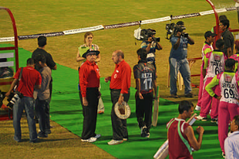
My first match was the following night when I was in the middle with Dave Brandon. It is a little ironical that I have known Dave for a number of years and, despite taking my white coat to Wales when Joy and I stayed with him during the summer, we had to travel some thousands of miles before we could umpire a match together. Stepping out onto the field for the first time in front of 45,000 shouting and cheering fans was awesome. The adrenaline was certainly flowing and not made any better by the sight of the TV cameraman who was walking out backwards whilst pointing his running camera up our nostrils. I became acutely aware of Jeff Evans’s comments to me when he said, “Don’t worry about the cameras, there are only twenty-six of them and they only capture every move you make”. He was soon to be proved right. He also gave me further sound advice when he told me to “Enjoy the atmosphere and by the end of the first over it will be just like any other cricket match you’ve ever umpired”. What great words of wisdom they proved to be and I thought of them on many occasions during the next six weeks.

Umpiring televised cricket is different. During that first match I was reminded by Shakeel, who was third umpire, that when at the striker’s end I needed to stand about a foot to the right of my normal position or I was obstructing the view of the camera. I also had to refrain from giving my own decision for a stumping and/or run out, unless it was obvious, because both the fans at the ground and the armchair viewers enjoyed the excitement of waiting for the decision to be displayed on the big screen. I had one run out appeal where the batsman was home by at least a yard when the ’keeper splattered all three stumps out of the ground. I sent that one upstairs just to give me time to remake the wicket before play resumed! It was not long before my decision making was questioned. I had two challenges in that first match, both of which went in my favour. A good start and a very enjoyable match.

One thing I never expected was the attention of the crowd after each match. Once we had completed the match report and had a meal we headed off to the car park to find that we were swamped by fans wanting autographs and, in particular, to be photographed with the umpires. Whilst I was in India I signed match tickets, 4/6 posters, scraps of paper, shirts and even bank notes. My next official duty was three days later when I was third umpire with Dave Orchard and Shakeel out in the middle. This was certainly a new experience for me and what an introduction it proved to be. Alongside me in the box was the match referee, on this occasion Ajit Wadekar, the official scorer, the statistician and an official of the ICL who was basically at our beck and call. There were also frequent visits from members of the commentary team, namely Tony Greig, Dean Jones and Pat Symcox. I was directly in front of the one and only TV monitor on top of which was my control panel giving me access to the stump microphone, TV commentary (which was never used) and, most importantly a radio link with Tim, the TV director.

During play it could get quite noisy in the box but the minute a decision or appeal was referred upstairs you could hear a pin drop. Total silence and I could sense every eye in the room on me. Like most people I have sat in front of the TV screen at home and made secret decisions, but with the boot on the other foot, knowing that half the world is awaiting your decision changes your perspective. A couple of line decisions came upstairs that were straightforward but then the inevitable happened – the lights went out! What happens next? It was up to me to work out how much time was lost and how many overs were left to play upon resumption. Fortunately the VJD (India’s equivalent to Duckworth/Lewis) score is calculated by the statistician once he is given the time lost and overs remaining. In the event no calculations were required as the management team decided that the full twenty overs would be completed.

My only other outing in Hyderabad was as field umpire with Allan Jones for the match between Delhi Giants and Royal Bengal Tigers. My outstanding memory of this match was my first encounter with Paul Nixon. Paul to my mind typifies many wicket-keepers - noisy, full of enthusiasm and encouragement, banter bordering on sledging but, when asked to keep quiet, he does. I found him to be very pleasant and got on well with him throughout the tournament. If only he wouldn’t play that dreaded reverse sweep so often! This match was also straightforward. I had another decision referred that again went in my favour. . . . . . . . . . . . Keith
[to be continued]
PAGE THREE

FIELDCRAFT

COPING WITH PRESSURE

Pressure exists in all walks of life and how individuals deal with it differs enormously. The way people cope with pressure will depend largely on their personality type and usually there is little that a person can do to change this fundamental characteristic. Some people respond well to pressure and operate at their best and most efficient when pressure is at its greatest, others will react very badly under pressure even breaking down completely in extreme cases. As in many sports, psychology plays a big part in the game of cricket and the players will attempt to apply pressure on their opponents in order to gain an advantage. Bowlers will try to exert pressure on batsmen by bowling ‘line and length’ and employing astute field placings. Batsmen will try to impose pressure on the fielding side by displaying a solid defence to accurate bowling whilst scoring freely, from anything short of a length or off line, with aggressive shots. Some players will even resort to less subtle methods to apply pressure on opponents such as sledging. One thing is certain, however, that the players of both sides in the contest will put the umpires under pressure!

The role and responsibility of the umpire means that there will be necessary demands on the on-field officials from before the call of “Play” until after the call of “Time”. Some of these pressures are internal and coping with them will depend on the individual’s personality type. Others are external, often applied by the players or the state of the match. This article attempts to deal with these external pressures and how an umpire can cope with them. These extra demands on an official’s control of the game may include frequent and often aggressive appealing by the fielding side; chorus appeals for LBW and catches, when some of those appealing could not possibly be aware of the details of the events from their fielding position; the striker pointing to his bat following an appeal for LBW or rubbing his arm when there has been an appeal for a catch behind; the bowler questioning a decision in an aggressive manner; ‘verbal conflict’ between the batsmen and members of the fielding side; loss of concentration or a poor decision by the umpire.

Whatever the reason for the additional pressure, the situation has to be dealt with by the umpire concerned. If he reacts badly to the pressure it can adversely affect his performance. It can lead to tightness in the muscles, breathing difficulties, tiredness, increased heart rate, butterflies in the stomach, a lump in the throat and general anxiety. This in turn can lead to lapses in concentration, lack of focus, loss of confidence, poor decision making, loss of control and, worst of all, loss of the players’ respect. The tension causes his attention to become narrow and internally focused and he withdraws into himself. The players will soon realise the situation and, rather than approach it with sympathy and understanding, their appeals will increase in both frequency and volume.

To cope with the situation the umpire must try to relax, flex the neck and shoulder muscles to relieve the tension, try to breathe normally, taking deep slow breaths when the circumstances of play permit, clear the mind of irrelevant thoughts and re-focus on the NEXT BALL. He must replace negative thoughts with positive ones and put any apparent ‘mistake’ out of mind.


It is important to remember that no umpire is alone on the field of play, he has a partner. It is vital that the officials function as a TEAM. They should ‘communicate’ regularly, making eye contact after every delivery, and they should meet up as often as circumstances permit without causing any delays in play. They should support each other in every way possible throughout the match. Cricket may be a game of two halves but it is also a game of two ‘ends’. Nobody knows in advance how each ‘end’ is going to play; at which end it will be easier to bat; at which end a bowler will get more assistance from the pitch; and, most importantly, at which end the majority of appeals and decisions will occur. Each partner must cope with the events under his own jurisdiction and face the pressures that accrue. However, not only must each umpire realise when he himself is ‘under pressure’, he should also recognise when his colleague is ‘suffering’. He should be ready to offer moral and practical support whenever possible without ever undermining his partner’s authority in the eyes of the players. Remember that “a problem shared is a problem halved”.
The Instructor

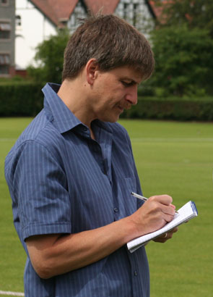
Ian's Diary 08
Photo: © John Boomer by Ian Callender

Week ending July 11
The rain on Saturday in the NCU left me with no choice but to head North West for the Irish Cup quarter final between Donemana and Waringstown. There was a delayed start here as well we still got 35 overs-a-side and the game turned into a classic. Donemana, put in, made 191 for seven, despite McCallan taking three for 20 in his seven overs and the visitors needed seven off the last over with four wickets left. It was even easier for Waringstown after Peter Hanna hit the first ball for four but then the wheels came off, Gary Kidd was stumped, brother Stuart was caught at third man and the last two balls were both ‘dots’. Donemana won by two runs! Next day was supposed to be Twenty20 finals day, instead it was the reserve day for the group games but it was still raining so all the games were reduced to bowl-outs. I went to Carrickfergus where the Stormont Spitfires won the three-way battle between Cliftonville and the hosts. It needed a phone call by the umpires to tournament organiser Richard Johnson just to clarify the rules after all three teams each won a game. Carrick’s win, in the final match against the Spitfires, however, was in a sudden death shoot-out.
PAGE FOUR
So once the Spitfires had made it a 4-4 tie, they were through with a win and a half, against Cliftonville’s win and a defeat, even though both ‘hit’ seven times!
On Tuesday flew to Holland with the Ireland team for the Inter-Continental Cup game in Rotterdam and even without Trent Johnston and the three county players, there was still enough class to overpower the Dutch by an innings. Head and shoulders above the rest of the batsmen was Andre Botha who scored 172 but Peter Connell then completed a marvellous first class debut with a hat-trick and gave him 10 wickets in the match.
Week ending July 18
On holiday Monday it was off to Ballygomartin Road - to see a Premier League game. Homeless Cliftonville was hosting Instonians and it was a very entertaining run-feast. Instonians scored 281 for six (top score 59) and Cliftonville replied with 238 (top score 38 extras). Woodvale is still missed on the club circuit, not least for the quality of the teas and although they were not providing them today Peter White and I agreed on that when indulging in the excellent Cliftonville one.
The rest of the week was spent watching the Under 17s win the European Championship title, with some ease. On Tuesday I was at Saintfield to see Ireland win against Jersey and, unfortunately, there was one of the more unusual reasons for an extended lunch - the sightscreen fell on top of the father of Ireland’s Craig Averill. An ambulance was called for and had to drive across the outfield to attend to Mr Averill. He was taken to hospital for a check-up but, I was glad to report the next day, that he was able to return for the end of the match, more shocked than injured.
He was also at Stormont on Thursday for the tournament final between Ireland and Scotland, a game which highlighted the gulf in class between the teams, Ireland winning by nine wickets. The future continues to look rosy for Ireland.
Week ending July 25
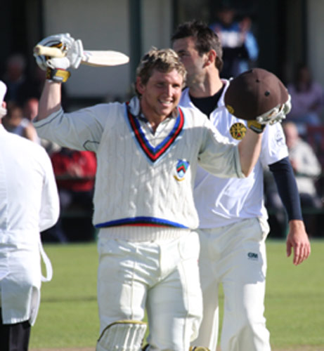
This was a landmark week because I wrote the last cricket column for the Ireland’s Saturday Night (the Ulster, the Pink, or simply the ISN, whatever you know it as) the paper closing after 114 years of business. I was asked why and the simplest reason was that it was no longer selling in economical numbers, the Saturday ’live’ action being overtaken by the internet, radio television and even the mobile phone. First though it was to The Green for the Challenge Cup semi final between North Down and Civil Service North. When I sent my penultimate report for the ISN, I said that 253 may not be enough for the holders and, sure enough, the Stormont side powered through to the final with the help of a magnificent century by Gary Wilson, freed for the weekend to play by Surrey. With Regan West hitting 93 not out Photo: © John Boomer - they shared a third wicket stand of 159 - the holders crashed to defeat with six overs to spare, the first in the cup outside the final for nine years!
Next day it was up to Beechgrove in time to see the Vaughan Valley (Twenty20) North West Cup final between Donemana and Brigade but primarily for Ireland’s last Twenty20 warm-up ahead of the next month’s World qualifiers. They were playing the North West Pros and won the game with a ball to spare, Thinus Fourie hitting the third and fifth balls of the last over for sixes. A whole four days off before I headed to Dublin for the European Championships and Ireland’s first game was against newcomers Norway. It should have been one of the miss-matches of the season, and it was, although Ireland did not play very well. They bowled the Pakistani Vikings out for 119 but it took them 43.1 overs and lost two wickets in chasing the runs. At least they have plenty of time to get it right. There are 13 more days' international cricket in the next 19.
Ian

February Puzzler

This month’s puzzler is, in fact, 3 questions BASED ON NCU PLAYING REGULATIONS & BYE LAWS taken directly from the power-point presentation given at our January meeting & are reproduced here for the benefit of those who were not in attendance, to test their wits & to check the memory cells of those who were present.

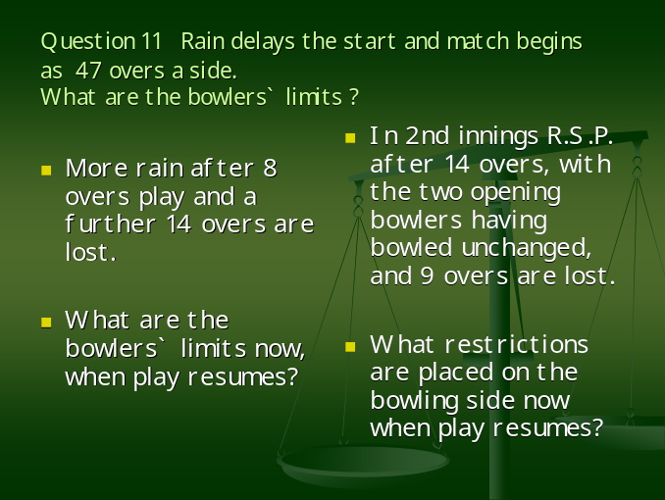
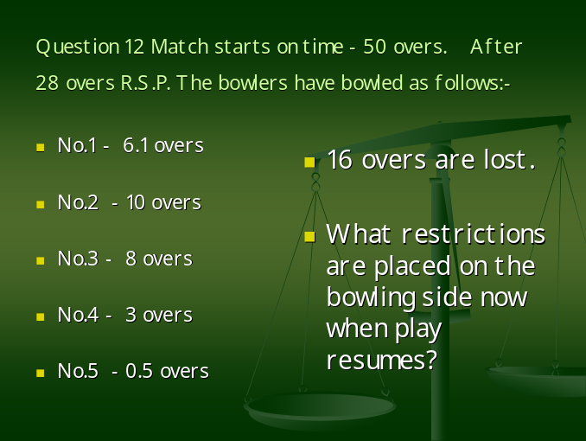
PAGE FIVE
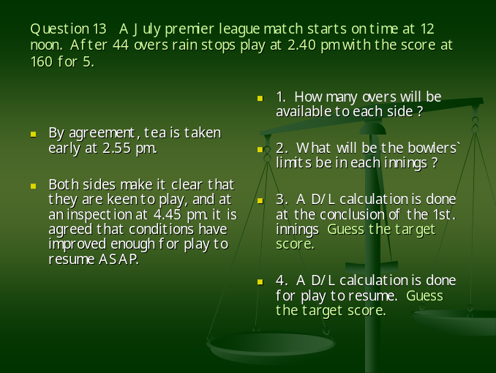

December Answers

Remember the Questions?

LET`S THINK L.B.W.

1. A delivery hits the striker’s front pad which is just outside the line of the off stump. You are quite certain that the ball would have gone on to hit the wicket. Give all the reasons why, nevertheless, you would give the striker not out LBW.
2. A right arm over the wicket bowler pitches the ball outside the line of the off stump. The ball hits the striker’s pad. What are the facts of which the umpire must be certain, in order to be able to give the striker out LBW on appeal?

The Answers!

1. [i] The delivery was a No Ball.
[ii] The striker made an attempt to play the ball with his bat.
[iii] The ball touched the striker’s bat or hand [glove] holding the bat before hitting the pad.

2. [i] It was not a No Ball.
[ii] The first interception was on the striker’s person, not the bat or hand [glove] holding the bat.
[iii] The point of impact was either
[a] in line between wicket and wicket or
[b] was outside the line of off stump and the striker made no genuine attempt to play the ball with his bat.
[iv] That he had seen sufficient of the ball’s travel after pitching to be sure of the path it was on.
[v] That this path meant that the ball would have hit the wicket but for the interception.

The Puzzler

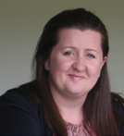
Your Secretary Speaks
Photo: © Cricketireland.org

Dear Colleagues,

SATURDAY, FEBRUARY 21ST at The Pavilion Complex, Stormont is a must for all your new 2009 diaries. It marks the date of the first annual workshop, seminar & conference under the auspices of our newly created all-Ireland umbrella association [ICUSA] following the demise of ACU&S last year.

ICUSA Annual Conference 2009
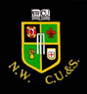
Irish Cricket Umpires & Scorers Association
Chairman: Murray Power - Hon Sec/Treas: Alan Waugh
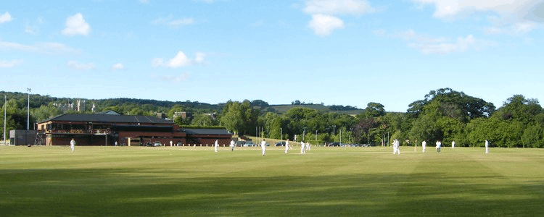
© Cricketireland.org

As this year’s event is being hosted by ourselves in NIACUS, it is even more imperative that we all make an effort to attend & make an active contribution to what promises to be a worthwhile, entertaining & instructional get-together.

The day will start with tea and coffee around 10.30 a.m. Lunch is of course provided, and we would hope to finish around 4.00 p.m.

Louis Fourie, who has just recently been appointed to the ICC Europe Elite Umpiring Panel, will be giving a comprehensive presentation on match management.

Keith Smith has also kindly agreed to do a presentation on his experiences in India which included players being able to challenge a limited number of decisions and the involvement of the TV umpire.

Trevor Magee will be providing feedback from the seminar on the new ICC Europe training arrangements that he and Keith are attending later this month at Lords. There will be plenty of other chat and discussion during the day, and the Committee hopes that in our 60th anniversary year, there will be a great turn out from within NIACUS.
PAGE SIX
I would be most obliged if you could confirm as soon as possible (but by Sunday 15th February at the very latest) if you will be attending, as I will need to confirm numbers for catering. As it is necessary to attend one in every three annual conferences in order to maintain your grade, why not make it easy and attend this one?
Judith

[Ed. Umpires on the e-mailing list will have received this info by the wonders of science. Others will be receiving an SAE & letter. So no excuses. Any of you who haven’t yet been contacted in either form let me know. ALL members welcome.]

NIACUS Umpire Training 2009

NIACUS has decided to embark on a new format for this year’s winter training course. In previous years the training has been conducted over 8 consecutive weeks, and we have had very disappointing attendances.
With umpiring numbers shrinking year on year, it is essential that the NCU Clubs support us by providing volunteers to attend our training courses. If they do not, the service that we provide to NCU will collapse. So we are trying something new.

This year’s course - the new ECB Level 1 - will be run over a single weekend, provisionally Sat. 7th. & Sun. 8th March 2009, at a Belfast venue.
The course is suitable for new aspiring umpires, 'Associate Member Umpires', coaches/teachers and players. It is also a most useful 'refresher' for existing panel umpires, and the short exam at the conclusion of day two, will give attendees the necessary 1st. level umpire qualification.
Last winter, we instigated the 'Associate Member' umpire’s scheme - following a meeting with some senior captains - whereby Clubs sent one or two people to attend a basic course. Those brave souls undertook to repay us by guaranteeing to stand in at least two or three matches during the following season. It was only a modest beginning, but NIACUS [and its hard pressed Appointments Sec. Ian Houston] was grateful to Stuart Hegarty & Jake Torrens [Derriaghy], Richard (master-race-person) Johnson [Instonians] and Carl Williams [Ballymena] for their response and support. It is essential that the Clubs persevere with this scheme and provide us with a steady stream of new blood, so that we in turn can provide competent officials for Ulster cricket, next season and in the future.
Applications to attend this 2009 training weekend should be made ASAP, on our soon to be published confirmation of the date and details, to one of the following:
Chief Instructor: Keith Smith 7 Moygannon Rd. Donaghcloney, BT66 7NB. H.Tel. 028 3888 1155 E-mail keithsmith7mr@aol.com
Hon Secretary: Judith Hewitt 12 Ashbury Pk. Bangor BT19 6TY. H.Tel. 028 9145 3746 E-mail judith.hewitt@virgin.net
Appointments Secretary: Ian Houston 7 Rockmount Pk. Bangor BT19 6AT M.Tel. 07889 275 548 - NO CALLS AFTER 10.00PM. PLEASE. E-mail ianatrockmount@hotmail.co.uk
PLO’H

AND FINALLY . . . . . [Courtesy of our blog editor Alan Chambers]

UMPIRE AT THE GATE

Just before the match, the Secretary received a message in his office from the turnstiles.
“There’s an Umpire down here with two friends! Wants to know if they can come in?”
“No,” replied the Secretary. “The man’s obviously lying!”
“How do you make that out?” said the gateman.
“Whoever heard of an umpire with two friends?” came the reply.

Date of Next Meeting
Monday 9th February

Featuring
MAGEE & NEILL
[& POSS McCAREY 2]

!!DON’T FORGET!!
COME ONE COME ALL & BRING BOB YOUR DONATIONS FOR THE DINNER BALLOT

PAGE SEVEN
aw08

